1



# BansilalRamnathAgarwalCharitableTrust’s

Vishwakarma Institute of Technology,Pune-37

*(AnautonomousInstitute ofSavitribai PhulePune University)*

**Department of Computer Engineering Lab Manual**

|  |  |  |  |
| --- | --- | --- | --- |
| **Course Code** | **Course Name** | **Lab Scheme(Hrs./Week)** | **Credits** |
| **CS3004** | **Cloud Computing** | **2** | **1** |

Course Outcomes:

1. To become familiar with cloud computing and its ecosystem

2. To acquire basics of virtualization and its importance

3. To evaluate in-depth analysis of Cloud Computing capabilities and its services.

4. To configure and implement storage services.

5. To analyze different cloud-based services to meet a set of given requirements.

6. To design security aspects for cloud computing

Class:- TY Branch: -CSE(AI)

Year: 2023-24 Prepared By: - Dr. Sangita M. Jaybhaye

Required Hardware: P-IV 8GB RAM

Required Software: Windows/Linux,VMWare/Virtual Box, Docker, Kubectl

**Index**

|  |  |  |  |  |
| --- | --- | --- | --- | --- |
| **SN** | **Title of Experiment** | **CO**  **Mapping** | **PO**  **Mapping** | **Page Number** |
| 1 | To install an OS using VirtualBox/ VMWare Workstation. Add Storage to create new virtual disk. | CO2 | PO2  PO3 | 03 |
| 2 | To setup AWS accounts and launch instances. | CO1 CO2 | PO2  PO3  PO5 | 09 |
| 3 | To create login into AWS and use S3 Bucket Service for storage  To work on different Cloud Storage Services. | CO4  CO5 | PO2  PO3  PO4  PO5 | 18  23 |
| 4 | To Deploy Virtual Machine on hypervisor such as KVM, ESXi. Take Backup and Migrate them. | CO2 | PO2  PO3  PO4  PSO2 | 34 |
| 5 | To install docker on window/linux and build docker image from docker hub. | CO3 | PO2  PO5  PSO3 | 40 |
| 6 | Deploy a stateless/stateful application on Kubernetes cluster. | CO3 | PO2  PO3  PO4  PO5  PSO3 | 49 |

# Experiment Number: 01

**Title:** To install an OS using VirtualBox/ VMWare Workstation. Add Storage to create new virtual disk.

|  |  |  |  |
| --- | --- | --- | --- |
| **Title of Experimentation** | **CO**  **Mapping** | **CO-Statements** | **PO**  **Mapping** |
| To install an OS using VirtualBox/ VMWare Workstation. Add Storage to create new virtual disk. | CO2 | To acquire basics of virtualization and its importance | PO2  PO3 |

# Installing Oracle VM VirtualBox

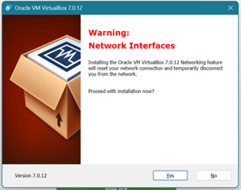

Downloading Oracle Virtual Box 7.0.12 and set-up. Specifying folder for installation.

**Step1:Download**

VirtualBox is a release made available by Oracle. Versions are available for download on the [VirtualBox Download](https://www.virtualbox.org/wiki/Downloads)website.

**Step2:Run.exefile**

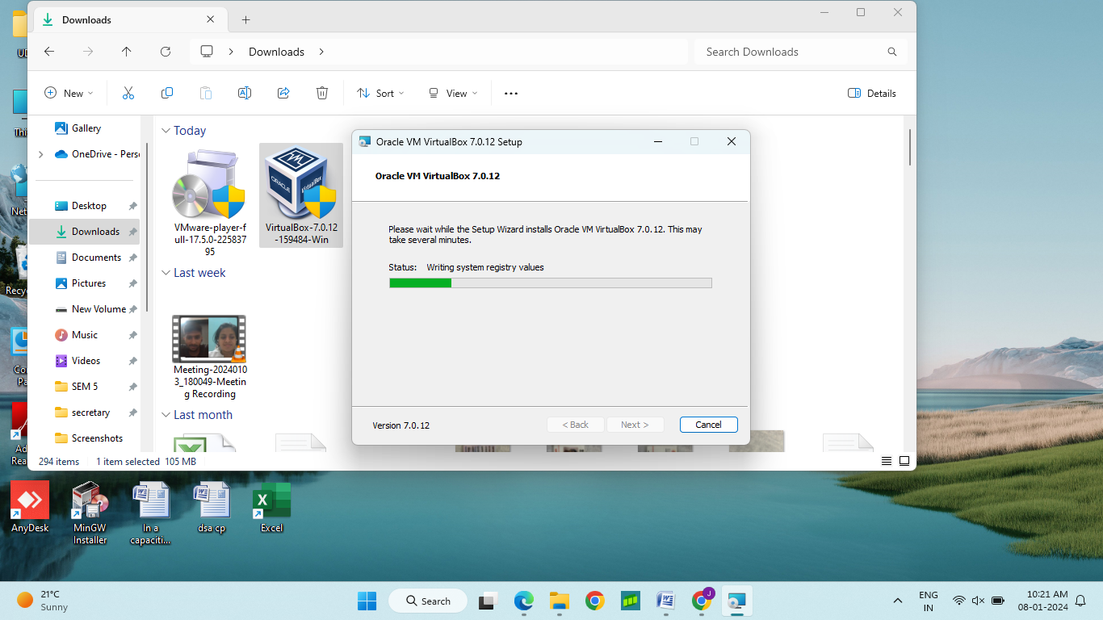

Once the software bundle has been downloaded, you can start the installation by double clicking on the file with the ending [.exe.](https://www.ionos.com/digitalguide/server/know-how/exe-file/)

**Step3:Deactivate any antivirus software**

Since an active antivirus program can negatively affect the installation process, it’s recommended to temporarily pause any antivirus software until all VirtualBox components have successfully been installed.

**Step4:Startthesetupwizard**

After you’ve opened the .exe file (after deactivating your antivirus program(s) and taken note of the User Account Control, the start screen of the VirtualBox setup wizard should appear automatically. Click on next to configure the installation settings, it will start the setup on the start-up screen

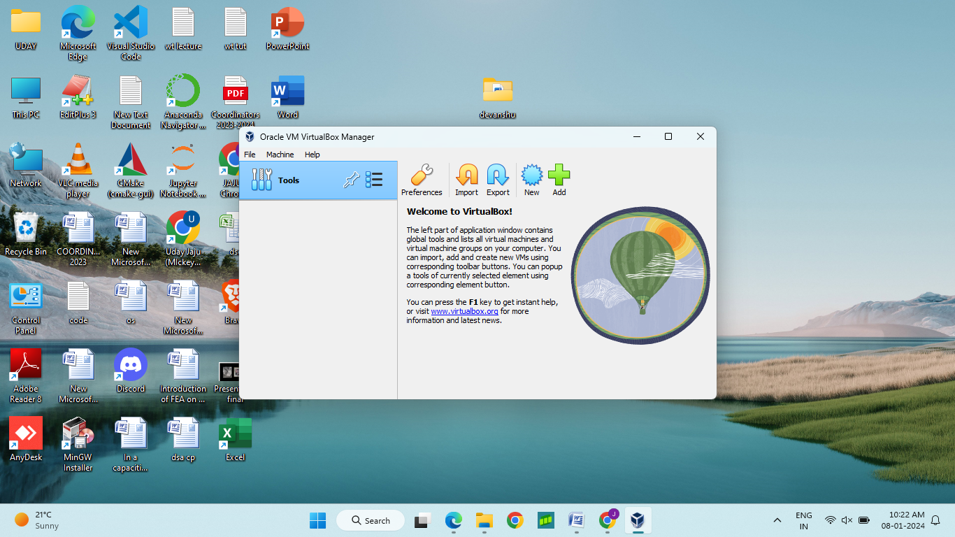

1. Adding Storage Capacity to it

This are the steps to add Virtual Machine in VB

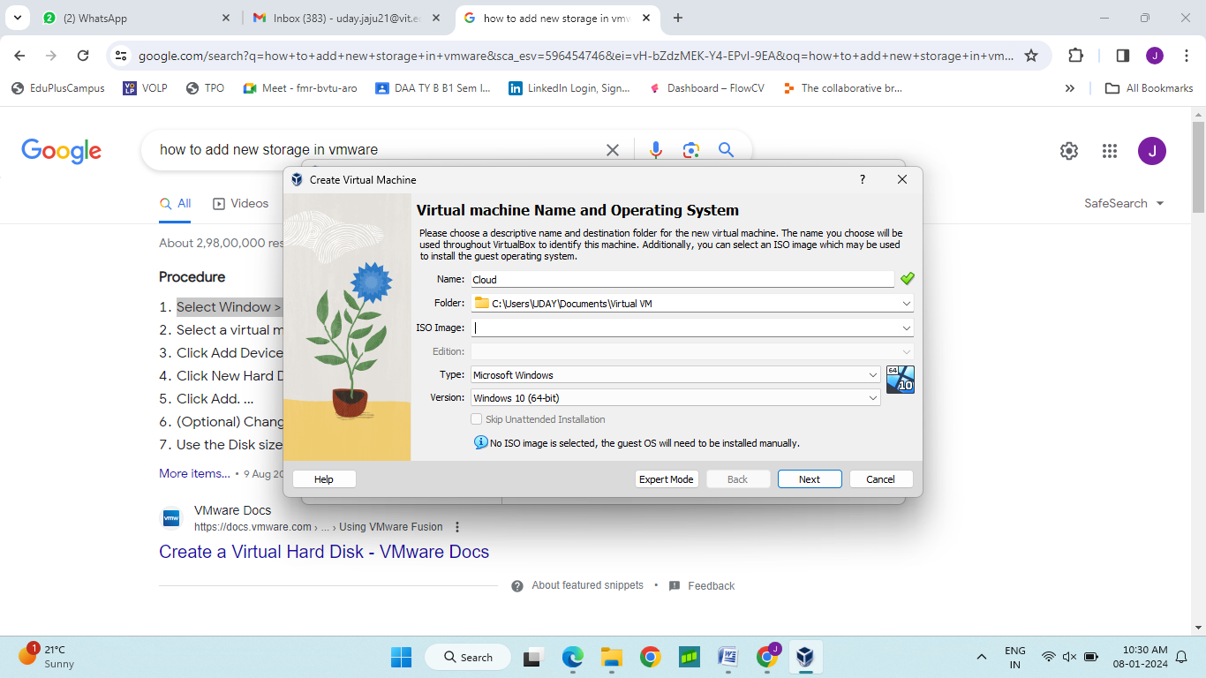

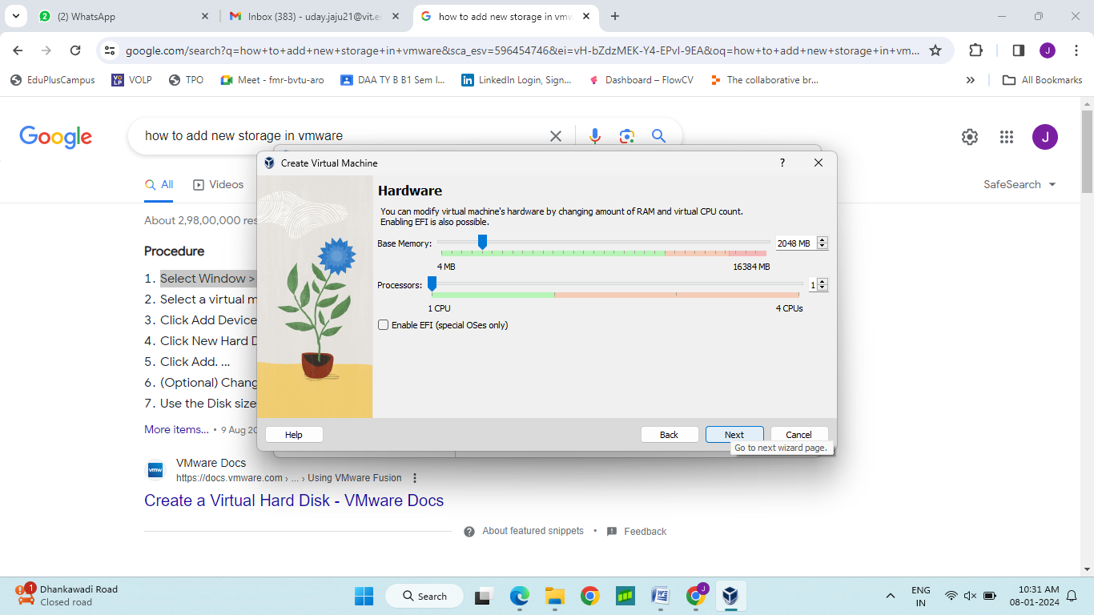

Here we can add storage to our Virtual Machine

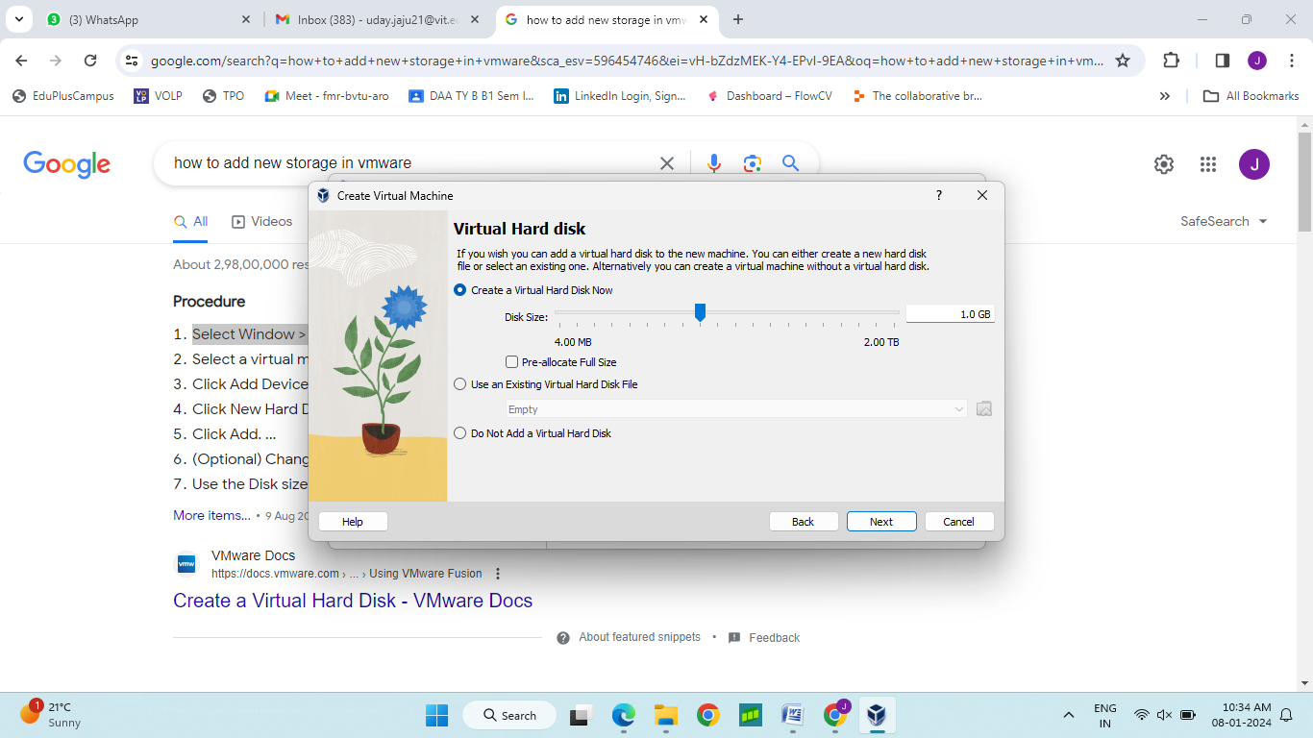

This we can see storage of 1GB is added to Virtual Machine

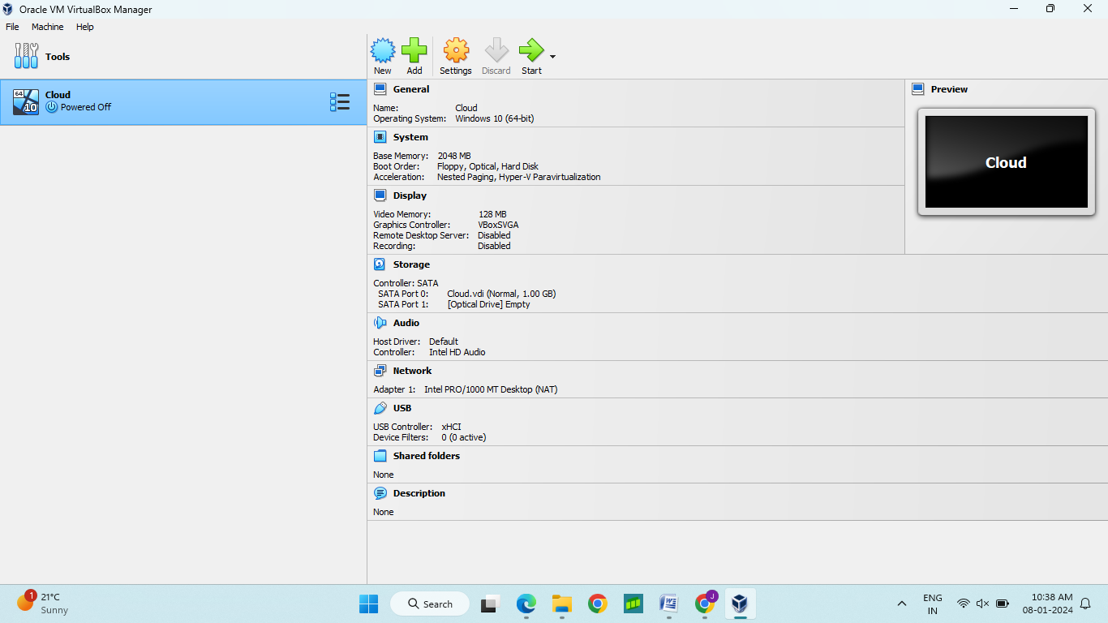

1. **Understanding Virtualization**:

A process to share hardware resources with other devices over internet and the hardware is at abstract level. Physical servers consume electricity, take up storage space, and need maintenance. Virtualization removes all these limitations by abstracting physical hardware functionality into software. By using Virtual Box, a Virtual Machine is set without worrying about hardware and the machine can use any OS without worrying about host machine OS. Select storage and disk size. Use ISO image for starting an instance.

**Virtual machine:** A virtual machine is a software-defined computer that runs on a physical computer with a separate operating system and computing resources. The physical computer is called the host machine and virtual machines are guest machines. Multiple virtual machines can run on a single physical machine. Virtual machines are abstracted from the computer hardware by a hypervisor.

**Hypervisor**

The hypervisor is a software component that manages multiple virtual machines in a computer. It ensures that each virtual machine gets the allocated resources and does not interfere with the operation of other virtual machines. There are two types of hypervisors.

**Type 1 hypervisor**

A type 1 hypervisor, or bare-metal hypervisor, is a hypervisor program installed directly on the computer’s hardware instead of the operating system. Due to better performance, it’s commonly used by enterprise applications. E.g. VMware ESXi hypervisor

**Type 2 hypervisor**

Hosted hypervisor or the type 2 hypervisor is installed on an operating system. Type 2 hypervisors are suitable for end-user computing. E.g. VMware Workstation/Oracle Virtual Box

**What are the different types of virtualization?**

1. **Server virtualization:** Server virtualization is a process that partitions a physical server into multiple virtual servers. It is an efficient and cost-effective way to use server resources and deploy IT services in an organization. Without server virtualization, physical servers use only a small amount of their processing capacities, which leave devices idle.
2. **Storage virtualization:**Storage virtualization combines the functions of physical storage devices such as network attached storage (NAS) and storage area network (SAN). Storage virtualization uses all physical data storage and creates a large unit of virtual storage that you can assign and control by using management software.
3. **Network virtualization**: Network virtualization is a process that combines all of these network resources to centralize administrative tasks. Administrators can adjust and control these elements virtually without touching the physical components, which greatly simplifies network management.
   1. **Software-defined networking:**Software-defined networking (SDN) controls traffic routing by taking over routing management from data routing in the physical environment.
   2. **Network function virtualization:** Network function virtualization technology combines the functions of network appliances, such as firewalls, load balancers, and traffic analyzers that work together, to improve network performance.
4. **Data virtualization:**Data virtualization creates a software layer between this data and the applications that need it. Data virtualization tools process an application’s data request and return results in a suitable format. Thus, organizations use data virtualization solutions to increase flexibility for data integration and support cross-functional data analysis.
5. **Application virtualization:** Application virtualization pulls out the functions of applications to run on operating systems other than the operating systems for which they were designed.

To achieve application virtualization

* 1. **Application streaming** – Users stream the application from a remote server, so it runs only on the end user's device when needed.
  2. **Server-based application virtualization** – Users can access the remote application from their browser or client interface without installing it.
  3. **Local application virtualization** – The application code is shipped with its own environment to run on all operating systems without changes.

1. **Desktop virtualization:**Desktop virtualization is used to run these different desktop operating systems on virtual machines, which your teams can access remotely. This type of virtualization makes desktop management efficient and secure, saving money on desktop hardware
2. **Virtual desktop infrastructure:** Virtual desktop infrastructure runs virtual desktops on a remote server.
3. **Local desktop virtualization:** Local desktop infrastructure runs the hypervisor on a local computer and create a virtual computer with a different operating system.

**How is virtualization different from cloud computing?**

1. Virtualization technology makes cloud computing possible. Cloud providers set up and maintain their own data centers. They create different virtual environments that use the underlying hardware resources.
2. Cloud computing is the on-demand delivery of computing resources over the internet with pay-as-you-go pricing. Instead of buying, owning, and maintaining a physical data center, you can access technology services, such as computing power, storage, and databases, as you need them from a cloud provider.

# Experiment Number:02

**Title: To setup AWS accounts and launch instances**

|  |  |  |  |
| --- | --- | --- | --- |
| **Title of Experimentation** | **CO**  **Mapping** | **CO-Statements** | **PO**  **Mapping** |
| To setup AWS accounts and launch instances | CO1 CO2 | 1. To become familiar with cloud computing and its ecosystem  2. To acquire basics of virtualization and its importance | PO2  PO3  PO5 |

1. **Setup AWS account: Setup Username and Enter Card details. (Continuing using my old account)**

Amazon Elastic Compute Cloud (Amazon EC2) provides on-demand, scalable computing capacity in the Amazon Web Services (AWS) Cloud. Using Amazon EC2 reduces hardware costs so you can develop and deploy applications faster.

1. **Launch EC2 instance**

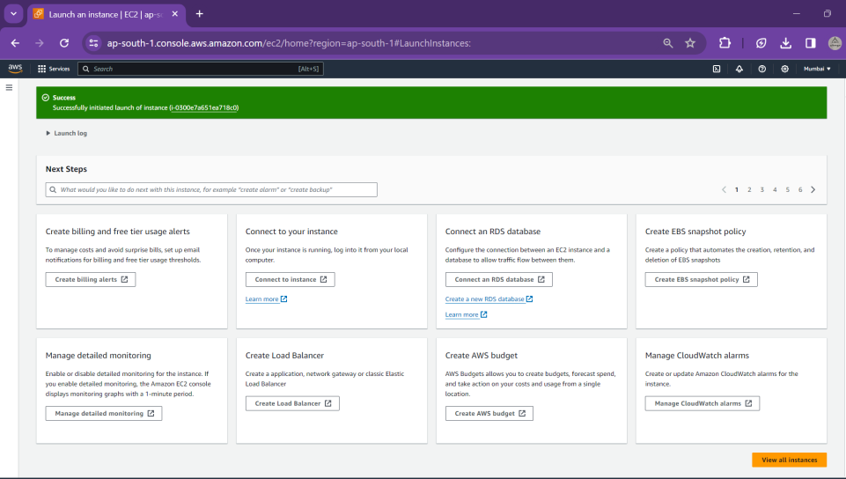

Instance ID is generated after launching.

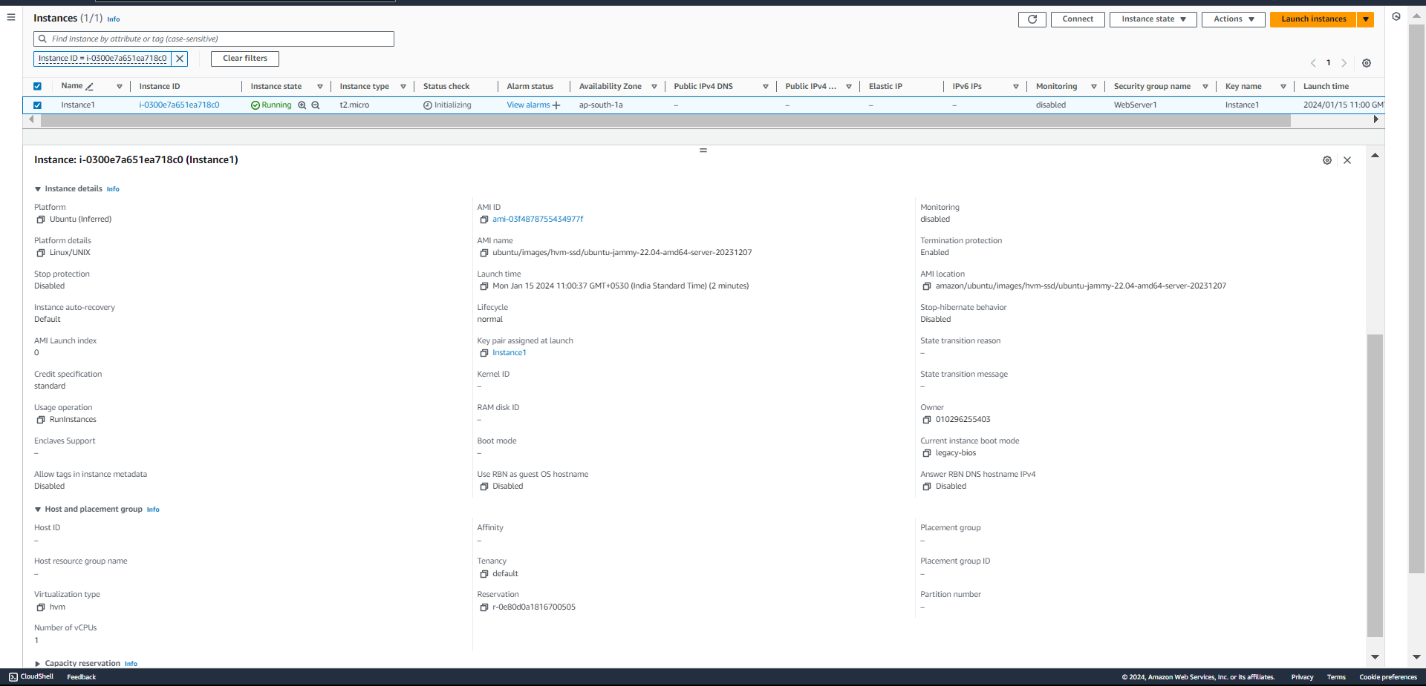

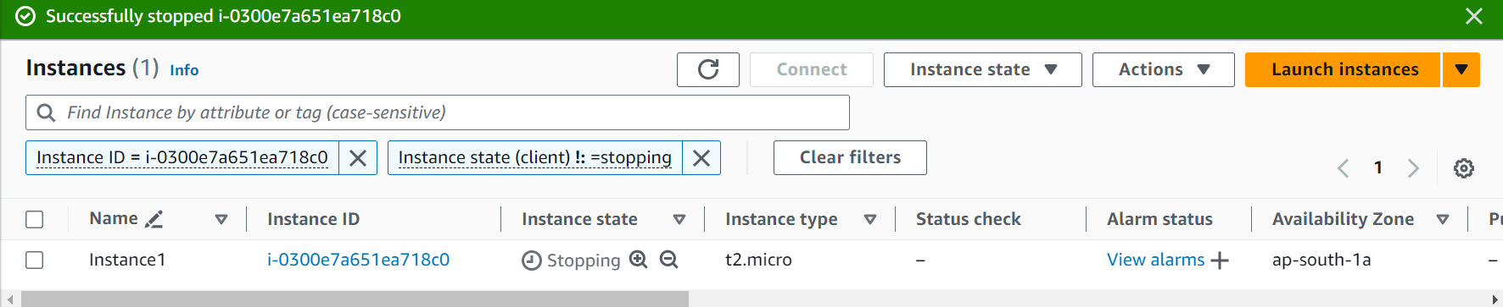

1. **Creation of Instance**
   1. **Create an Instance**

The virtualization type of your instance is determined by the AMI that you use to launch it. Current generation instance types support hardware virtual machine (HVM) only. Some previous generation instance types support paravirtual (PV) and some AWS Regions support PV instances

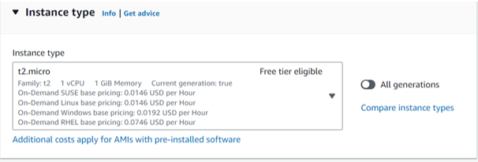

These instances provide a baseline level of CPU performance with the ability to burst to a higher level when required by your workload. An Unlimited instance can sustain high CPU performance for any period whenever required.

* 1. **Amazon Machine Image (AMI)**

Name and OS needs to be defined to choose an Amazon Machine Image (AMI). A variety of OS can be chosen including MacOS, Windows, Ubuntu, RedHat and types of Linux (Amazon, Suse,etc).

• An Amazon Machine Image (AMI) is a template that contains a software configuration (for example, an operating system, an application server, and applications). From an AMI, you launch an instance, which is a copy of the AMI running as a virtual server in the cloud.

An AMI includes the following:

• One or more Amazon Elastic Block Store (Amazon EBS) snapshots, or, for instance-store-backed AMIs, a template for the root volume of the instance (for example, an operating system, an application server, and applications).

• Launch permissions that control which AWS accounts can use the AMI to launch instances.

• A block device mapping that specifies the volumes to attach to the instance when it's launched.

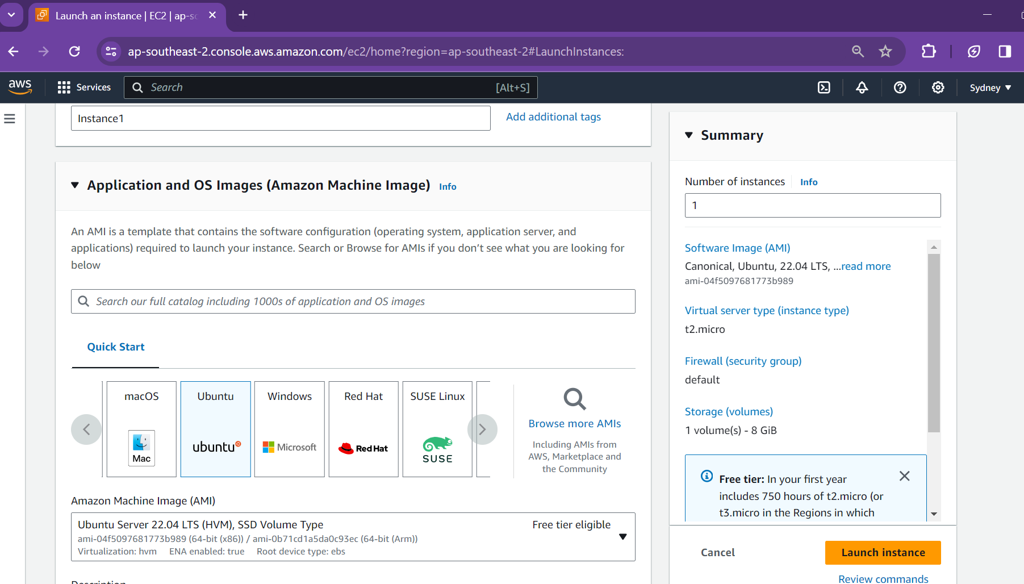

* 1. **Key Pair**

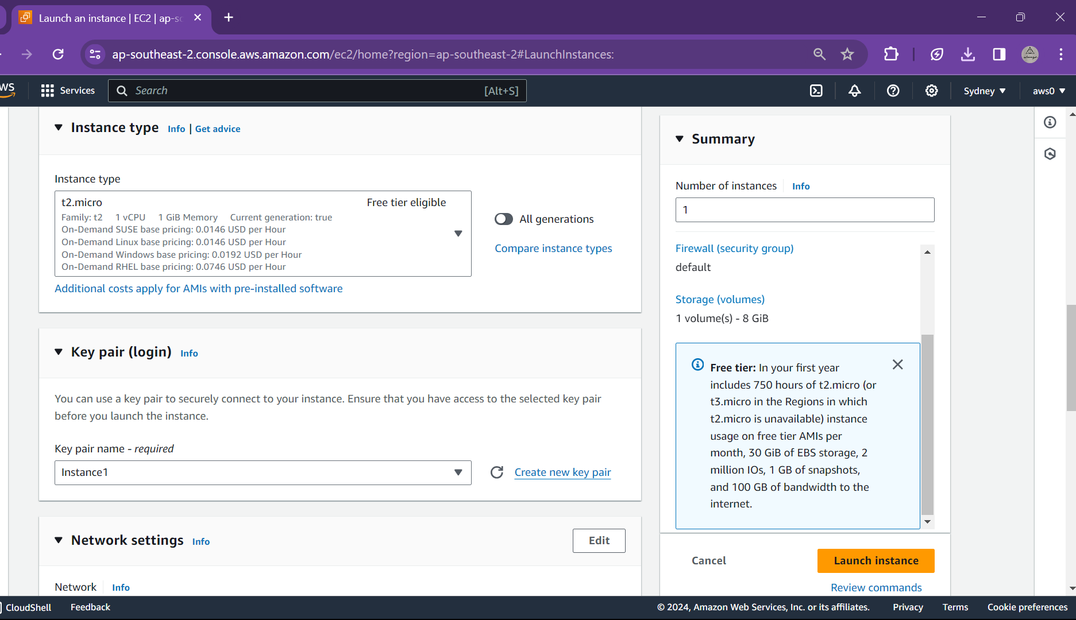

1. A key pair, consisting of a public key and a private key, is a set of security credentials that you use to prove your identity when connecting to an Amazon EC2 instance. Amazon EC2 stores the public key on your instance, and you store the private key. For Linux instances, the private key allows you to securely SSH into your instance.
2. AWS uses public-key cryptography to secure the login information for your instance. A Linux instance has no password; you use a key pair to log in to your instance securely. You specify the name of the key pair when you launch your instance, then provide the private key when you log in using SSH.
3. For Key pair type, choose either RSA or ED25519. Note that ED25519 keys are not supported for Windows instances.
4. A key pair is generated and .pem file is downloaded in downloads folder. It will be further used for connecting to local machine using SSH or RDP.
5. If not saved the key pair is lost and cannot be retrieved, so needs to be downloaded and saved properly
6. A command is used to set permissions in windows similar to chmod on Unix-like systems:

icacls "D:\Practical\VIT\Sem6\CloudStorage\Instance1.pem" /inheritance:r /grant:r "%username%:R"

This command removes any inherited permissions and grants read-only access specifically to the current user.

After running this command, you should be able to use your private key securely for SSH connections.

* 1. **Networking & Security**
* Amazon VPC enables to launch AWS resources, such as Amazon EC2 instances, into a virtual network dedicated to your AWS account, known as a virtual private cloud (VPC).
* The public IP address of an instance is associated with your instance only until it is stopped or terminated. If you require a persistent public IP address, you can allocate an Elastic IP address for your AWS account and associate it with an instance or a network interface.
* An Elastic IP address remains associated with your AWS account until you release it, and you can move it from one instance to another as needed.

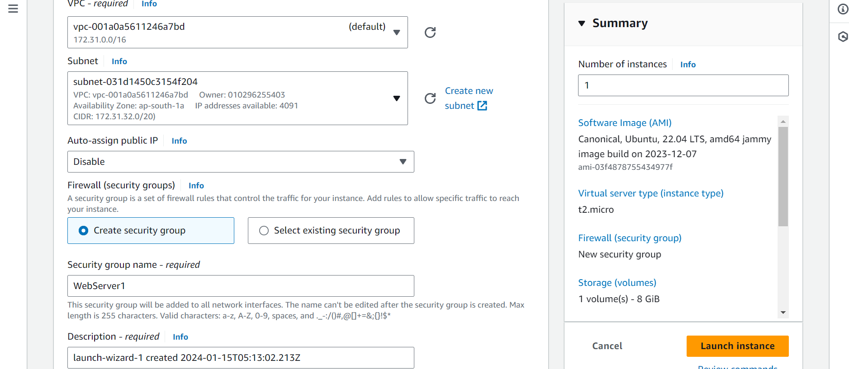

* A security group acts as a virtual firewall for your EC2 instances to control incoming and outgoing traffic.
* Inbound rules control the incoming traffic to your instance, and outbound rules control the outgoing traffic from your instance.

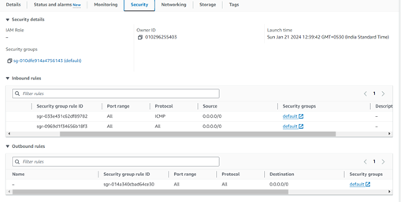

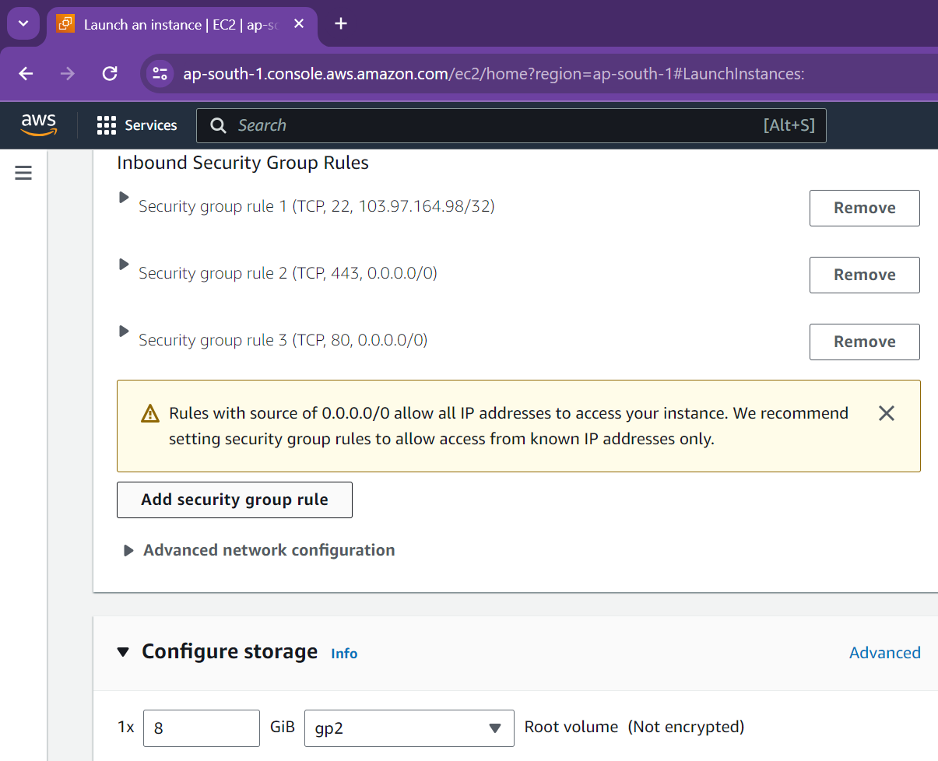

* 1. **Recovery Rules**

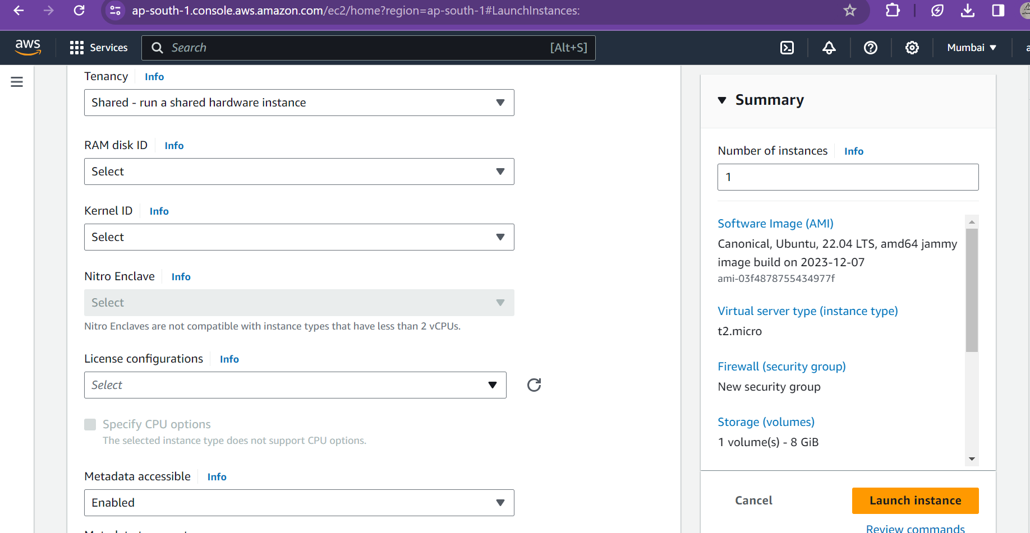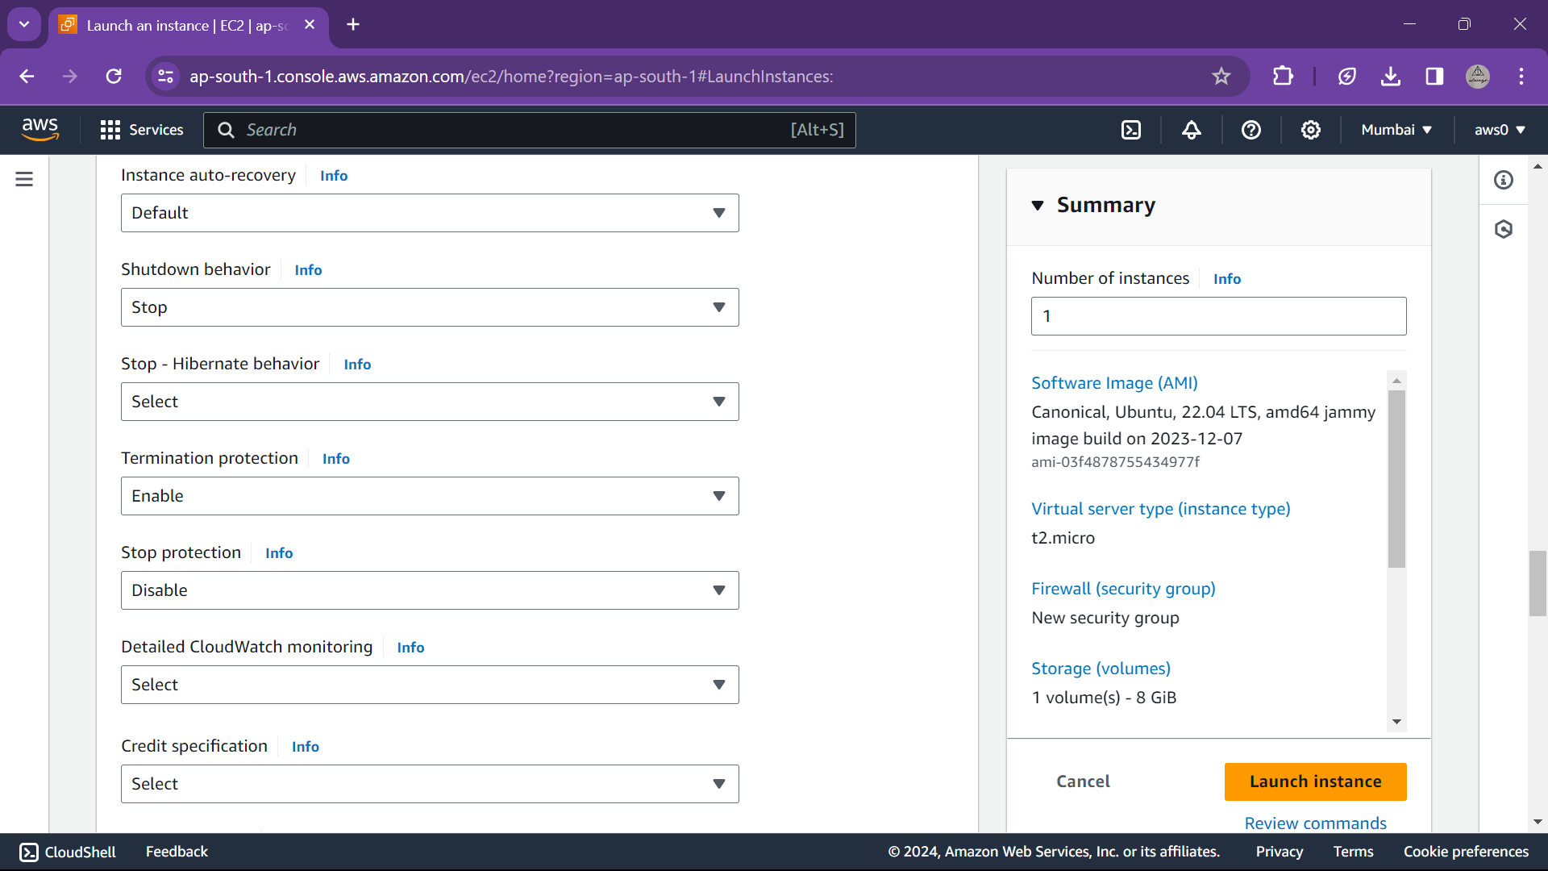  
Recovery rules like shutdown and termination process and auto recovery are specified

* 1. **Launch EC2**& its specification/description

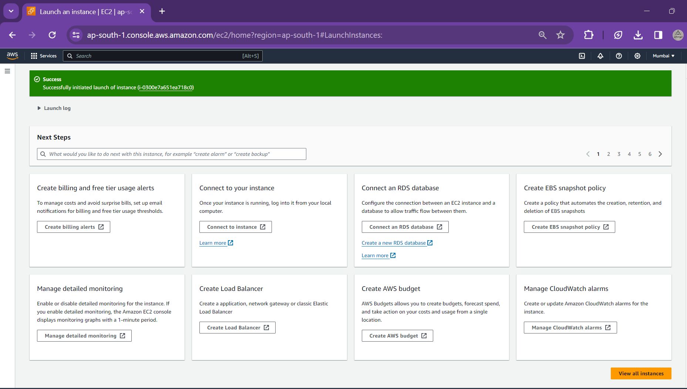



**Features of Amazon EC2**

**Instances:** Virtual servers.

**Compute optimized:** C5, C5n, C6g, C6gd, C6gn, C6id, C6i, C6in, C7a, C7g, C7gd, C7gn

**Memory optimized:** R, X, Z instances

**Storage optimized**: D, H, I

**Processor families**

a – AMD processors

g – AWS Graviton processors

i – Intel processors

**Current Generation (Sixth generation and later Amazon EC2 instance types)**

* General purpose: M6a, M6g, M6gd, M6i, M6id, M6idn, M6in, M7a, M7g, M7gd, M7i, T4g
* Compute optimized: C6a, C6g, C6gd, C6gn, C6i, C6id, C6in, C7a, C7g, C7gd, C7gn, C7i
* Memory optimized: R6a, R6g, R6gd, R6i, R7a, R7g, R7gd, R7i, R7iz, X2gd, X2idn, X2iedn
* Storage optimized: I4g, I4i, Im4gn, Is4gen
* Accelerated computing: DL2q, G5g, Inf2, P5, Trn1, Trn1n
* High-performance computing: Hpc6a, Hpc6id, Hpc7a, Hpc7g
* **Additional capabilities**

b – EBS optimized

d – Instance store volumes

n – Network and EBS optimized

e – Extra storage or memory

z – High performance

q – Qualcomm inference accelerators

flex – Flex instance

* **Instance families**

C – Compute optimized

D – Dense storage

F – FPGA

G – Graphics intensive

Hpc – High performance computing

I – Storage optimized

Is – Storage optimized with a one to six ratio of vCPU to memory

Inf – AWS Inferentia

Im – Storage optimized with a one to four ratio of vCPU to memory

M – General purpose

Mac – macOS

P – GPU accelerated

R – Memory optimized

T – Burstable performance

Trn – AWS Trainium

U – High memory

VT – Video transcoding

X – Memory intensive

1. **Amazon Machine Images (AMIs)**

Preconfigured templates for your instances that package the components you need for your server (including the operating system and additional software).

* **AMI virtualization types:** The virtualization type of your instance is determined by the AMI that you use to launch it. Current generation instance types support hardware virtual machine (HVM) only. Some previous generation instance types support paravirtual (PV) and some AWS Regions support PV instances.

1. **Instance types**

Various configurations of CPU, memory, storage, networking capacity, and graphics hardware for your instances.

1. **Key pairs**

Secure login information for your instances. AWS stores the public key and you store the private key in a secure place.

1. **Instance store volumes**

Storage volumes for temporary data that is deleted when you stop, hibernate, or terminate your instance.

1. **Amazon EBS volumes**

Persistent storage volumes for your data using Amazon Elastic Block Store (Amazon EBS).

1. **Regions, Availability Zones, Local Zones, AWS Outposts, and Wavelength Zones**

Multiple physical locations for your resources, such as instances and Amazon EBS volumes.

1. **Security groups**

A virtual firewall that allows you to specify the protocols, ports, and source IP ranges that can reach your instances, and the destination IP ranges to which your instances can connect.

1. **Elastic IP addresses**

Static IPv4 addresses for dynamic cloud computing.

1. **Tags**

Metadata that you can create and assign to your Amazon EC2 resources.

1. **Virtual private clouds (VPCs)**

Virtual networks you can create that are logically isolated from the rest of the AWS Cloud. You can optionally connect these virtual networks to your own network.

# Experiment Number: 03

**Title:** To create AWS account and use S3 storage bucket.

|  |  |  |  |
| --- | --- | --- | --- |
| **Title of Experimentation** | **CO**  **Mapping** | **CO-Statements** | **PO**  **Mapping** |
| To create AWS account and use S3 storage bucket | CO4  CO5 | 1. To configure and implement storage services. 2. To analyze different cloud-based services to meet a set of given requirements | PO2  PO3  PO4  PO5 |

**Theory:**

Amazon S3 is an object storage service that offers industry-leading scalability, data availability, security, and performance. It allows to store and protect any amount of data for a range of use cases, such as data lakes, websites, cloud-native applications, backups, archive, machine learning, and analytics for upto 12 months free. Its standard features include:

* 5 GB in the S3 Standard storage class
* 20,000 Get Requests
* 2,000 Put, Copy, Post, or List Requests

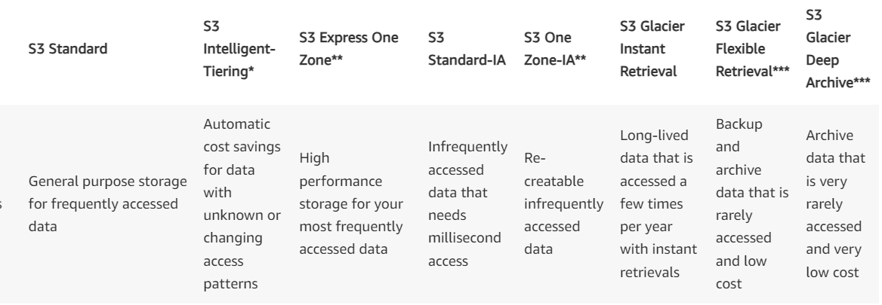

1. **Create a bucket**
   1. Sign in to the AWS Management Console and open the Amazon S3 console at https://console.aws.amazon.com/s3/.
   2. In the left navigation pane, choose Buckets.
   3. Choose Create bucket.
   4. The Create bucket page opens.
   5. For Bucket name, enter a unique name for your bucket (following the naming convention).
   6. After you create the bucket, you cannot change its name.

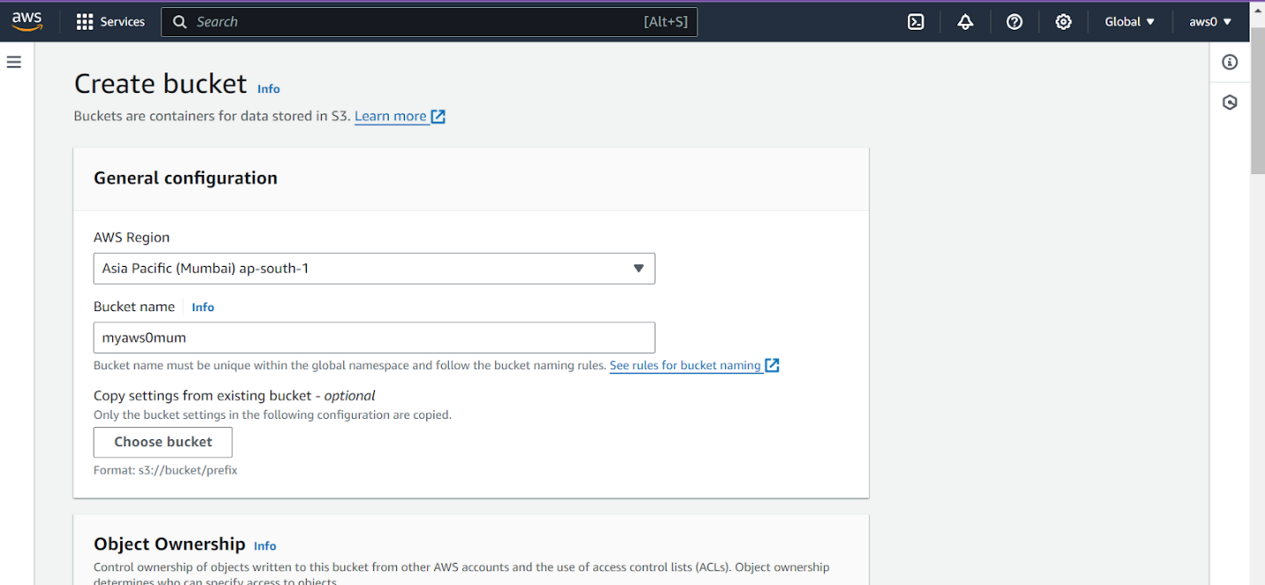

To create a bucket a region is selected and unique name is provided. We can also use existing bucket configuration using choose bucket button

**Bucket naming convention**: The bucket name must:

1. Be unique within a partition. A partition is a grouping of Regions. AWS currently has three partitions: aws (Standard Regions), aws-cn (China Regions), and aws-us-gov (AWS GovCloud (US) Regions).
2. Be between 3 and 63 characters long.
3. Consist only of lowercase letters, numbers, dots (.), and hyphens (-). Avoid using dots (.) in bucket names, except for buckets that are used only for static website hosting.
4. Begin and end with a letter or number.

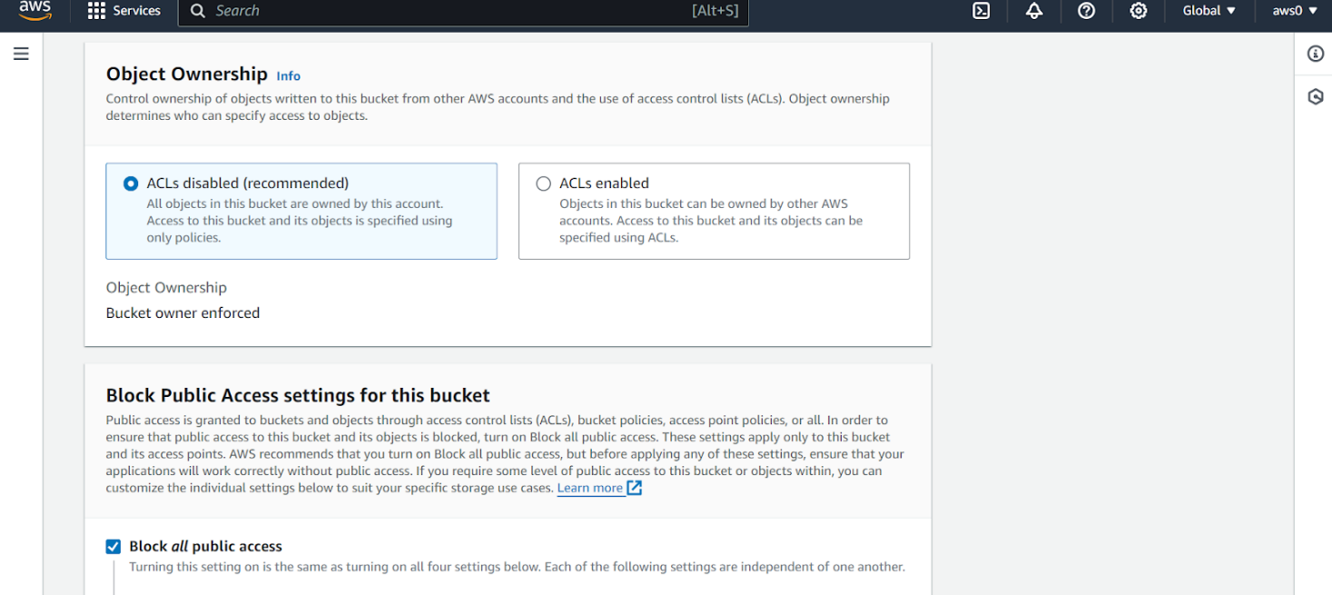

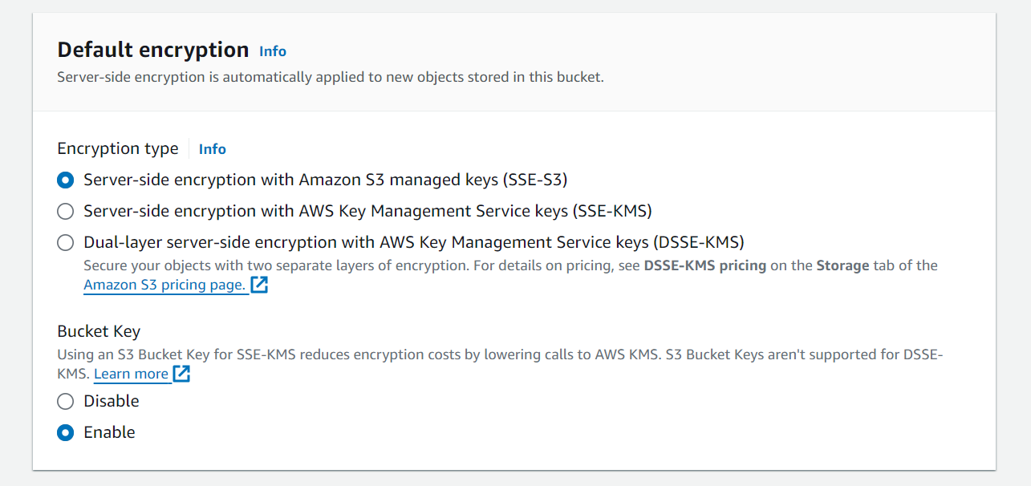

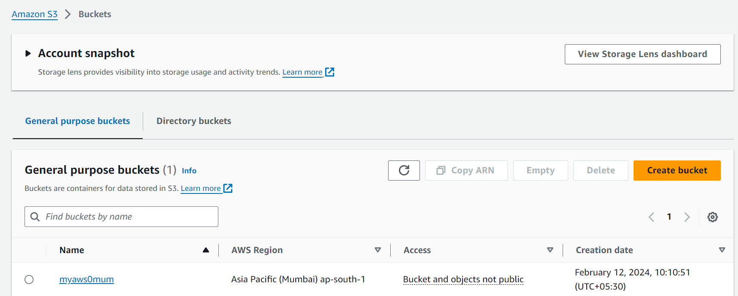

1. **Upload a file in a bucket:** To upload an object to a bucket
   1. Open the Amazon S3 console at https://console.aws.amazon.com/s3/.
   2. In the Buckets list, choose the name of the bucket that you want to upload your object to.
   3. On the Objects tab for your bucket, choose Upload.
   4. Under Files and folders, choose Add files.
   5. Choose a file to upload, and then choose Open.
   6. Choose Upload.



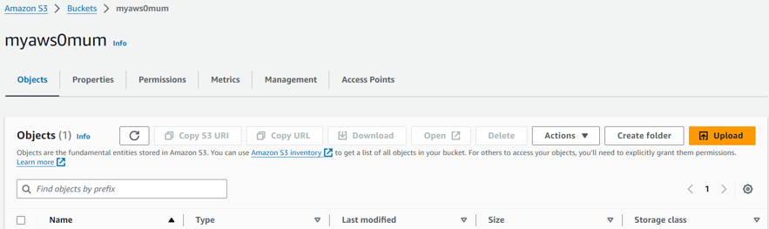

Click on bucket name & select objects tab to upload a new file.

Selecting the new file, the destination of storage folder is also displayed

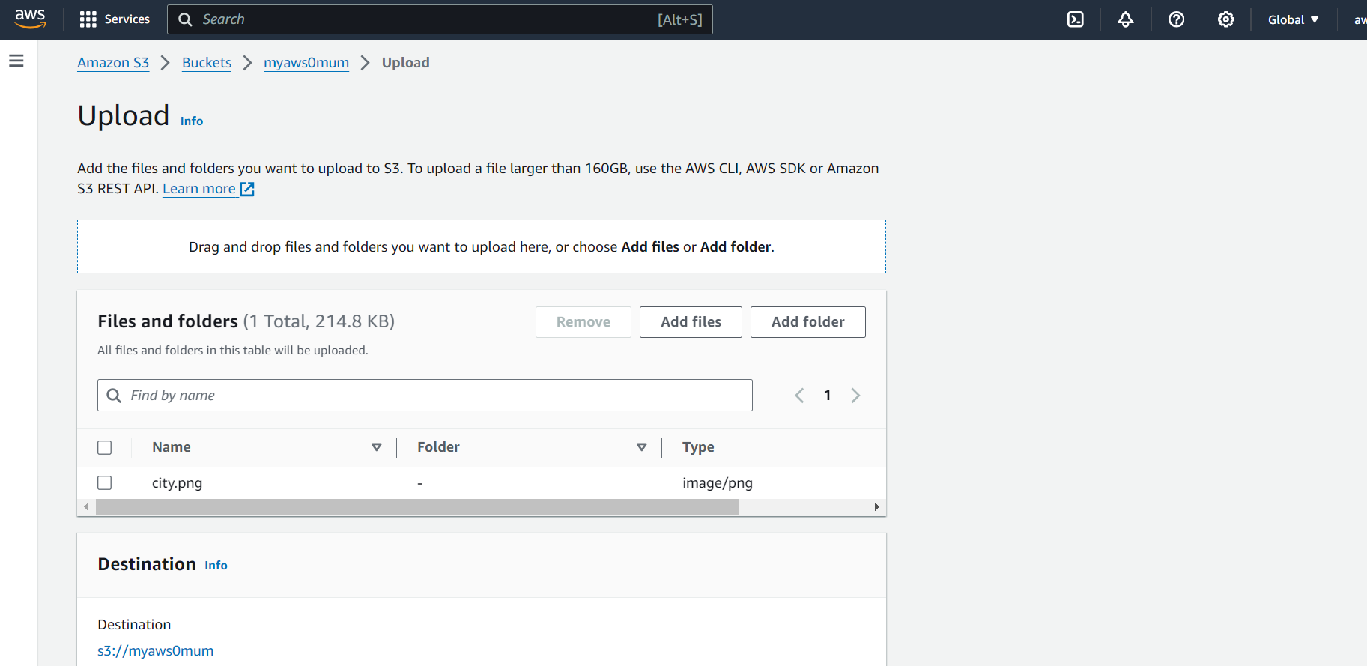

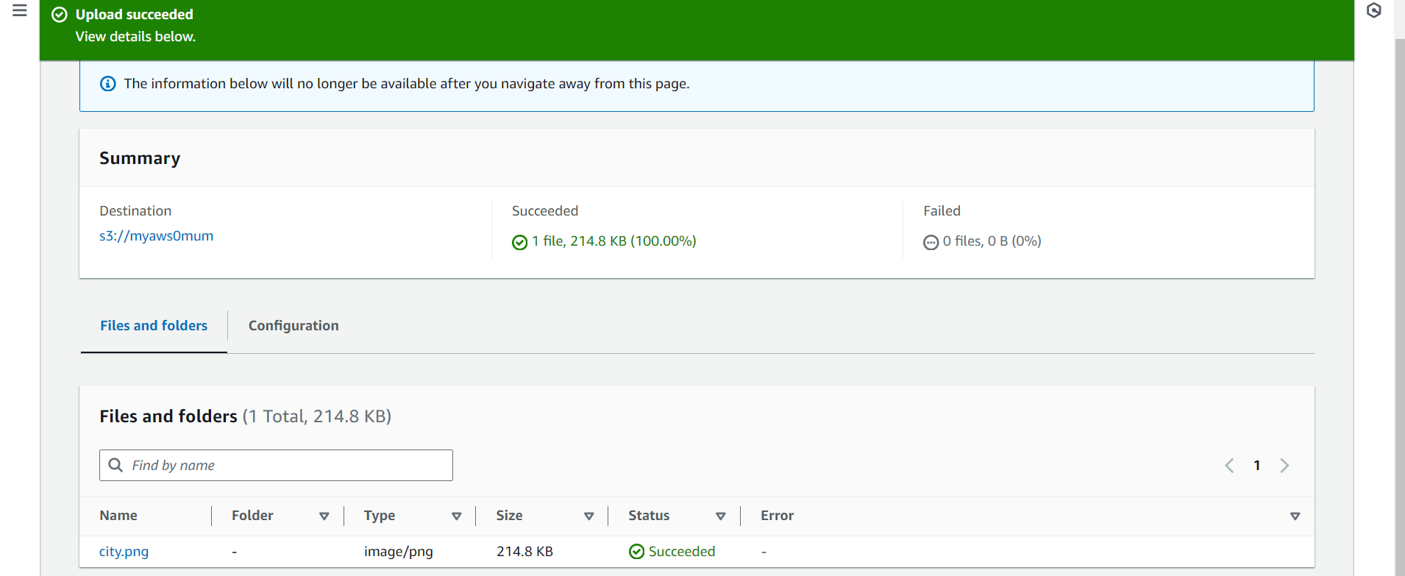

The size & properties of file is displayed after successful upload.

It further reflects in object dashboard.

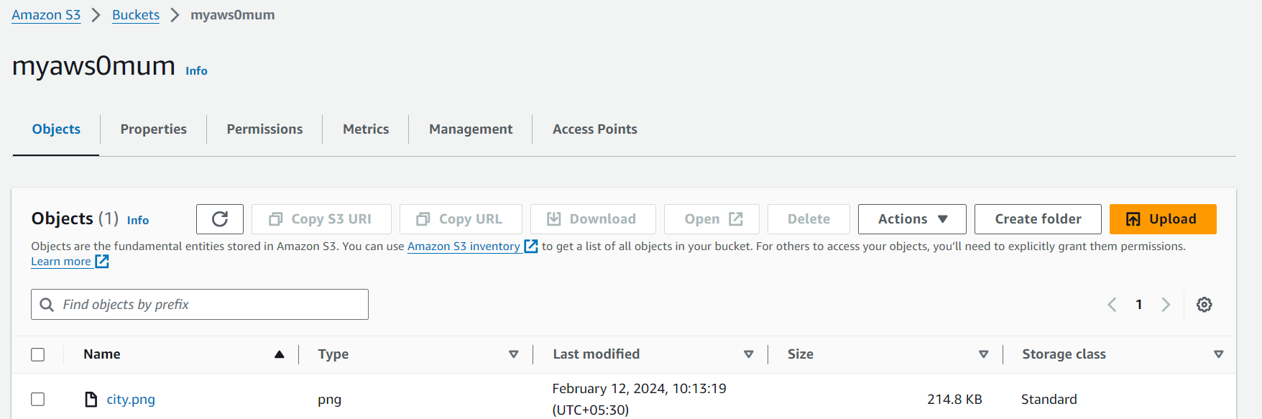

If you want to choose which objects you delete without emptying all the objects from your bucket, you can delete an object.

* In the Buckets list, choose the name of the bucket that you want to delete an object from.
* Select the object that you want to delete.
* Choose Delete from the options in the upper right.
* On the Delete objects page, type delete to confirm deletion of your objects.
* Choose Delete objects.

If you plan to delete your bucket, you must first empty your bucket, which deletes all the objects in the bucket.

To empty a bucket

* In the Buckets list, select the bucket that you want to empty, and then choose Empty.
* To confirm that you want to empty the bucket and delete all the objects in it, in Empty bucket, type permanently delete.

After you empty your bucket or delete all the objects from your bucket, you can delete your bucket.

* To delete a bucket, in the Buckets list, select the bucket.
* Choose Delete.
* To confirm deletion, in Delete bucket, type the name of the bucket.
* To delete your bucket, choose Delete bucket.

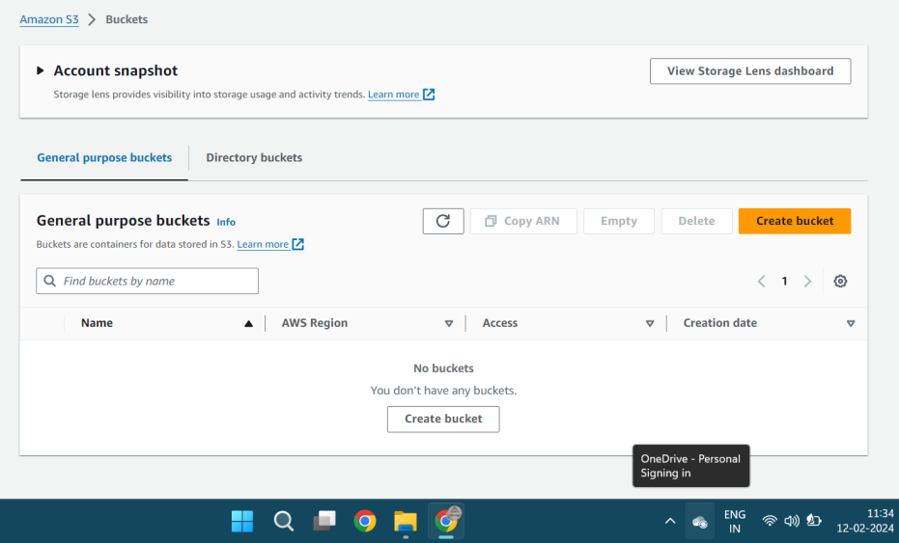

# Experiment Number: 04

**Title:** To Deploy Virtual Machine on Hypervisor such as KVM, ESXi. Take Backup and migrate them

|  |  |  |  |
| --- | --- | --- | --- |
| **Title of Experimentation** | **CO**  **Mapping** | **CO-Statements** | **PO**  **Mapping** |
| To Deploy Virtual Machine on Hypervisor such as KVM, ESXi. Take Backup and Migrate them | CO2 | To acquire basics of virtualization and its importance | PO2  PO3  PO4  PSO2 |

**Theory:** Process to share hardware resources with other devices over internet and the hardware is at abstract level. Physical servers consume electricity, take storage space, and need maintenance. Virtualization removes all these limitations by abstracting physical hardware functionality into software.

**Virtual machine:** A virtual machine is a software-defined computer that runs on a physical computer with a separate operating system and computing resources. The physical computer is called the host machine and virtual machines are guest machines. Multiple virtual machines can run on a single physical machine. Virtual machines are abstracted from the computer hardware by a hypervisor.

**Migration:** The movement of VMs from one resource to another, such as from one physical host to another physical host, or data store to data store, is known as VM migration. There are two types of VM migration: cold and live.

* Cold migration occurs when the VM is shut down.
* Live migration occurs while the VM is actually running.

**KVM or Kernel Virtual Machine**: Kernel Virtual Machine. KVM (for Kernel-based Virtual Machine) is a full virtualization solution for Linux on x86 hardware containing virtualization extensions that allows the kernel to function as a hypervisor.

**ESXi** is one of the primary components in the VMware infrastructure software suite.

**VMware ESXi** is an enterprise-class, type-1 hypervisor developed by VMware for deploying and serving virtual computers.ESXi is a Type 1 hypervisor, meaning it runs directly on system hardware without the need for an OS. As a type-1 hypervisor, ESXi is not a software application that is installed on an operating system; instead, it includes and integrates vital OS components, such as a kernel.

1. **Need a ready VM on Linux/ Ubuntu**

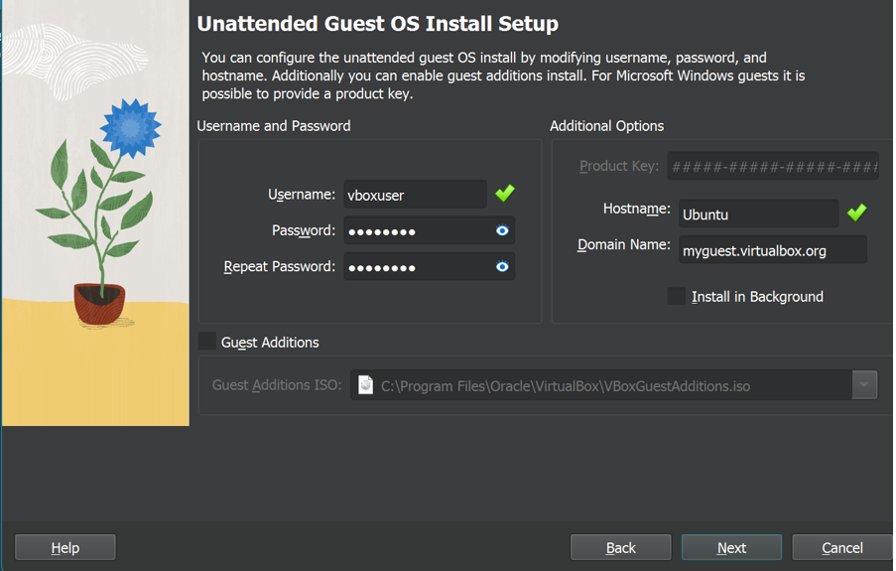

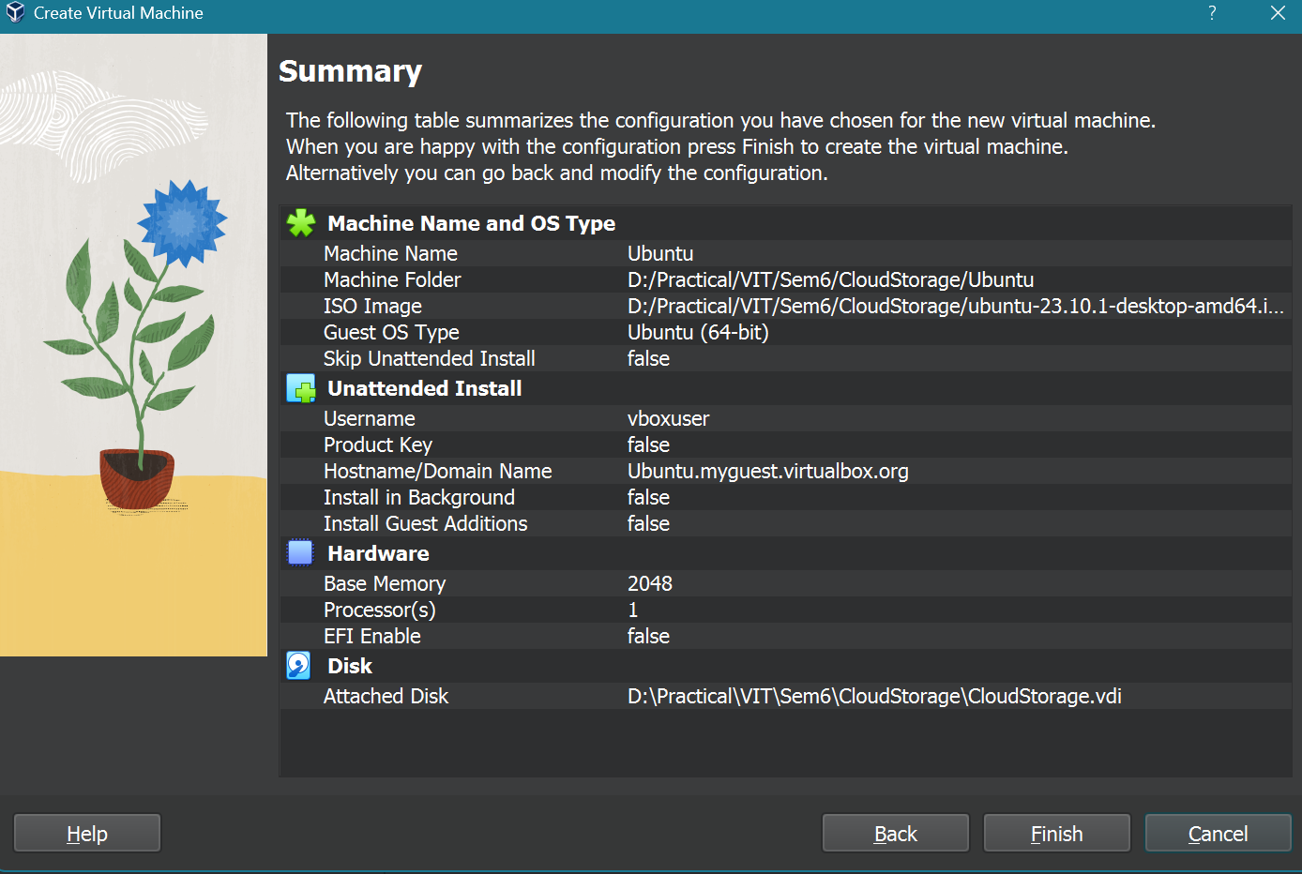

1. **Click on File and select ‘export appliances’. Select the virtual machine you would like to export.**

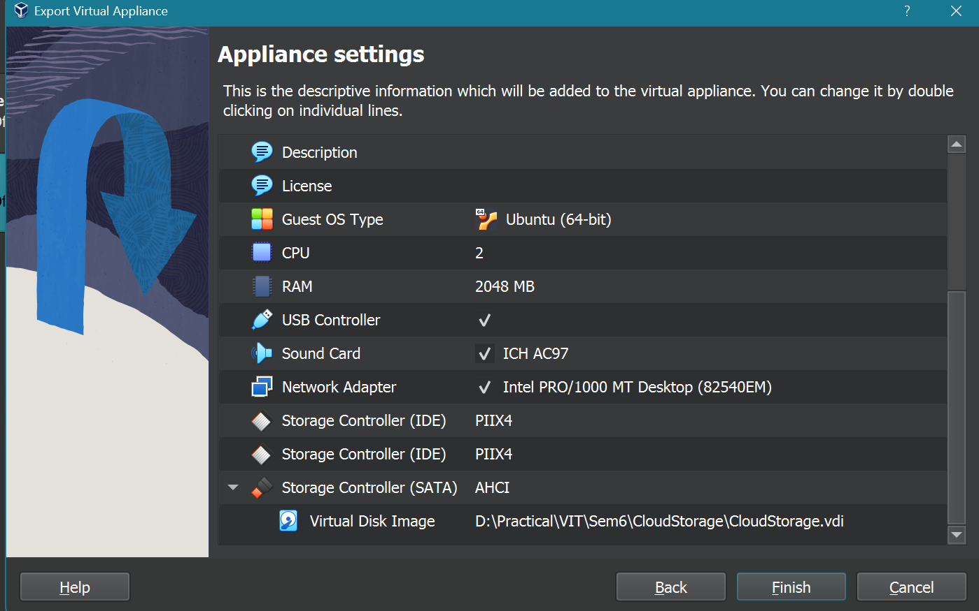

1. **Click on Next till its processing on the default settings(Select a dest folder for your file):**

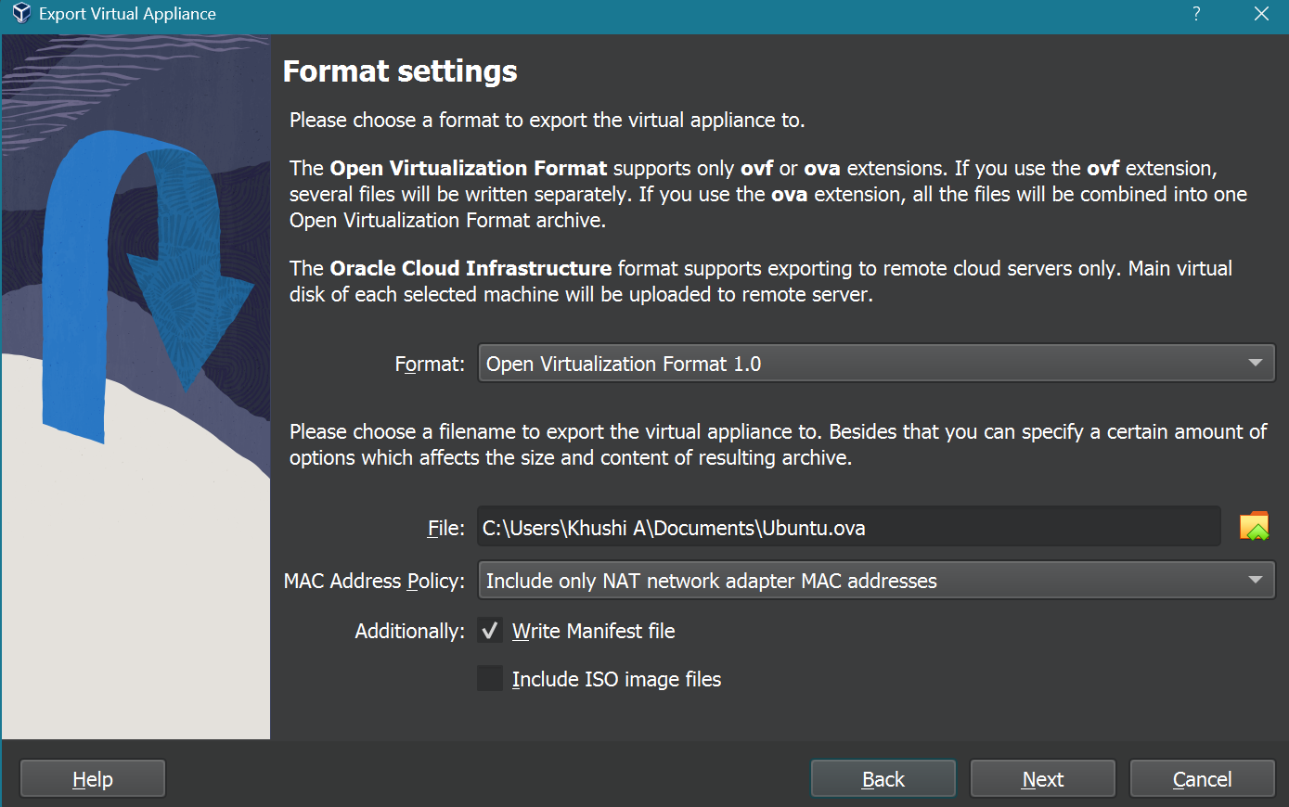

A file would be created which is your backup file.

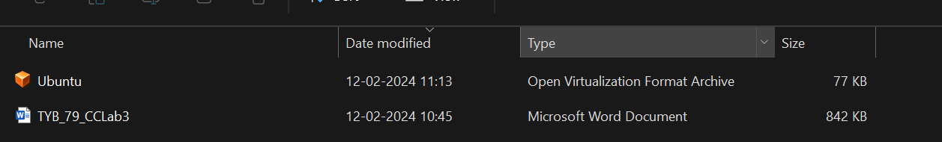

1. **Now go to Virtual Box dashboard to remove the backed up VM**

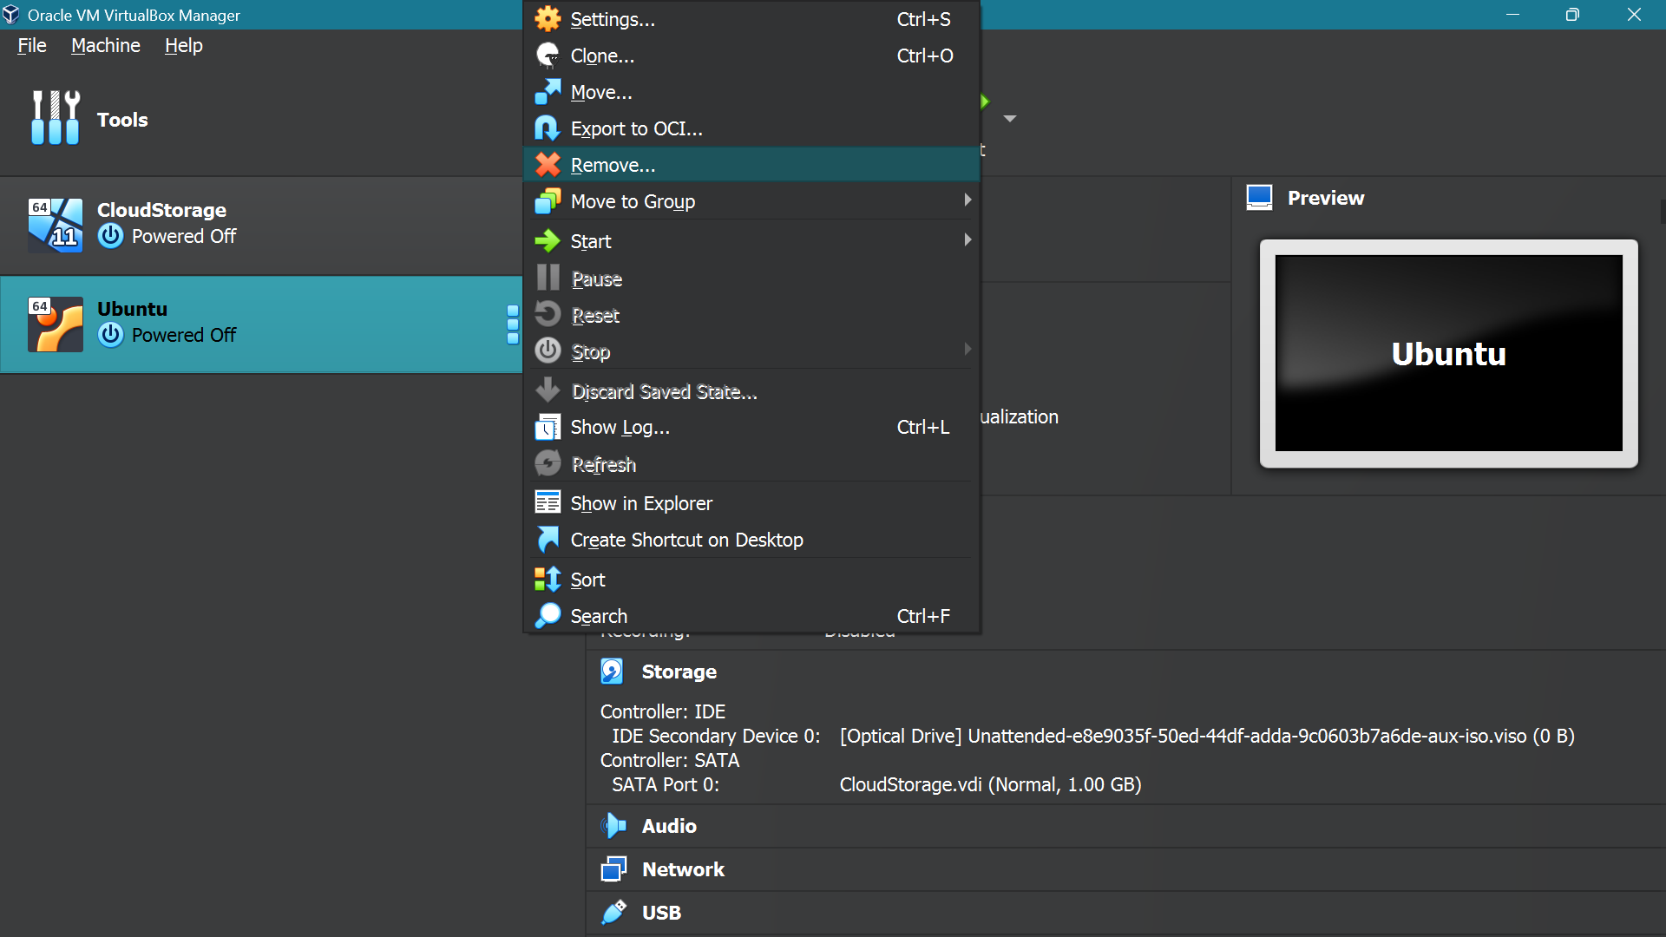

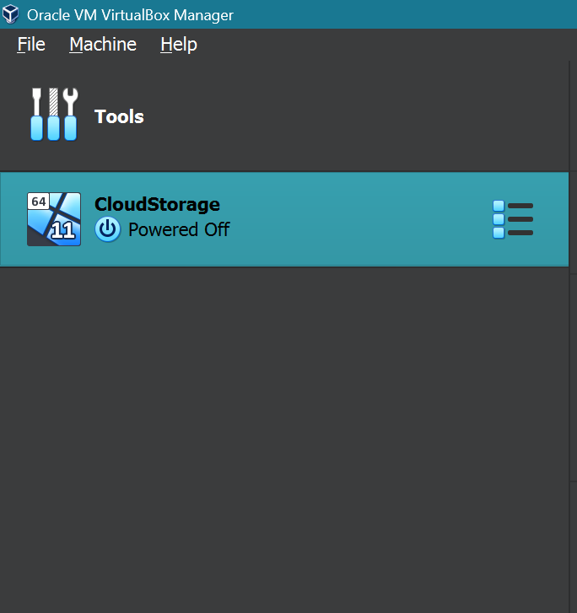

1. **Click on Import Appliances now and select the .ova backup file at your destination which you selected**

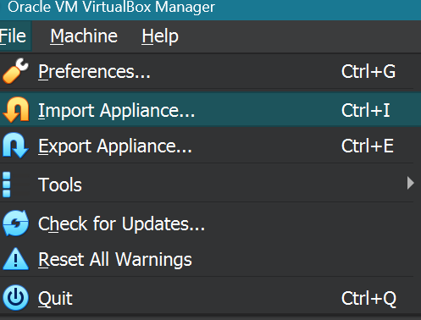

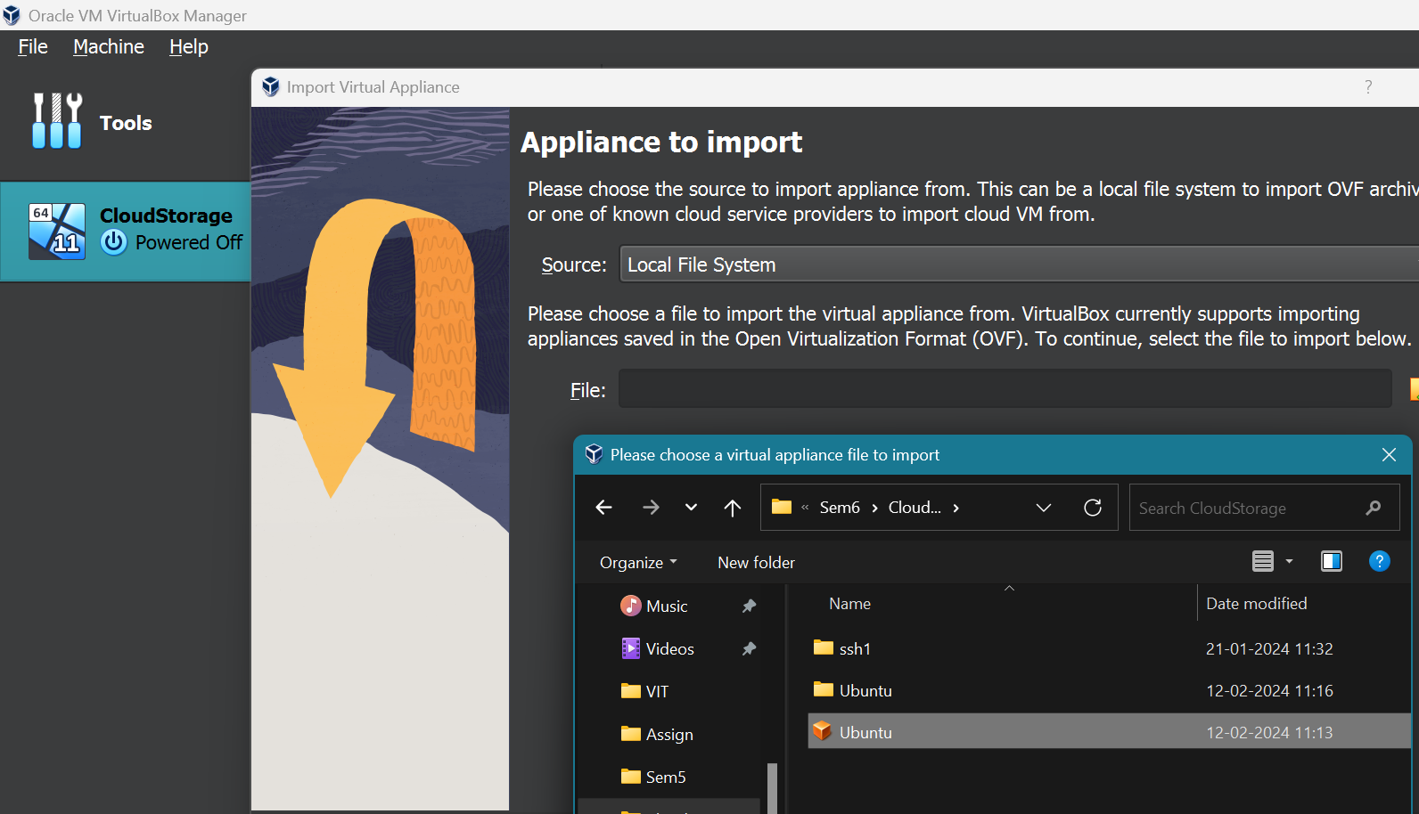

1. **Click on Import with the default settings:**

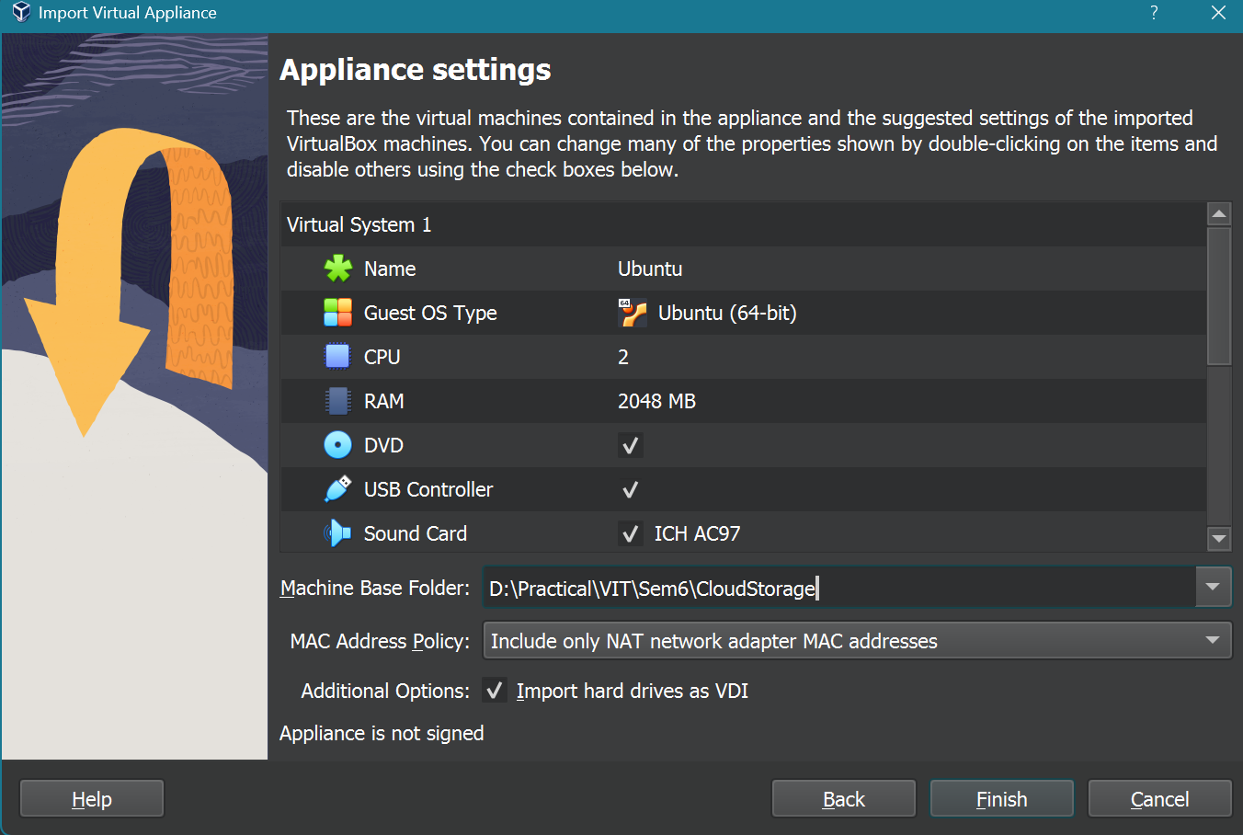

1. **Successfully Backed up and restored the VM using Cold migration:**

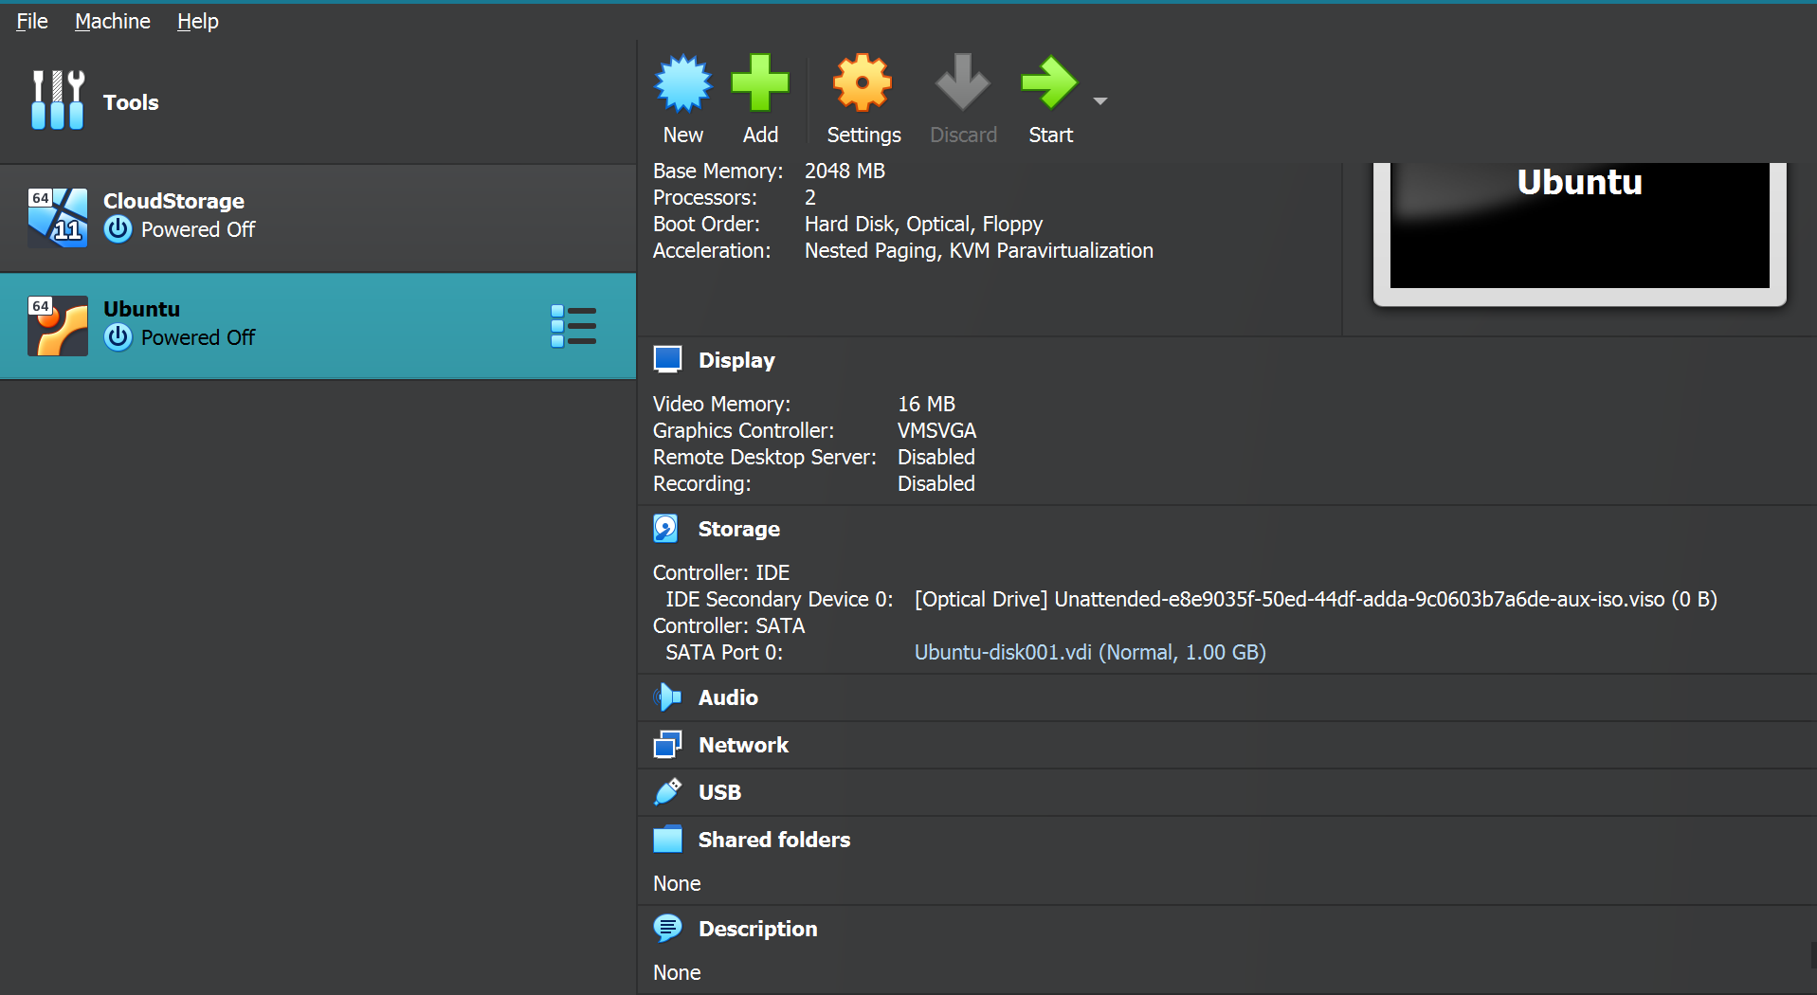

# Experiment Number: 05

**Title:** To install docker on window/linux and build docker image from docker hub.

|  |  |  |  |
| --- | --- | --- | --- |
| **Title of Experimentation** | **CO**  **Mapping** | **CO-Statements** | **PO**  **Mapping** |
| To install docker on window/linux and build docker image from docker hub. | CO3 | To evaluate in-depth analysis of Cloud Computing capabilities and its services | PO2  PO5  PSO3 |

# Theory:

* Docker is a software platform that allows you to build, test, and deploy applications quickly. Docker packages software into standardized units called containers that have everything the software needs to run including libraries, system tools, code, and runtime. Using Docker, you can quickly deploy and scale applications into any environment and know your code will run.
* Docker is written in the Go programming language and takes advantage of several features of the Linux kernel to deliver its functionality. Docker uses a technology called namespaces to provide the isolated workspace called the container. When you run a container, Docker creates a set of namespaces for that container.

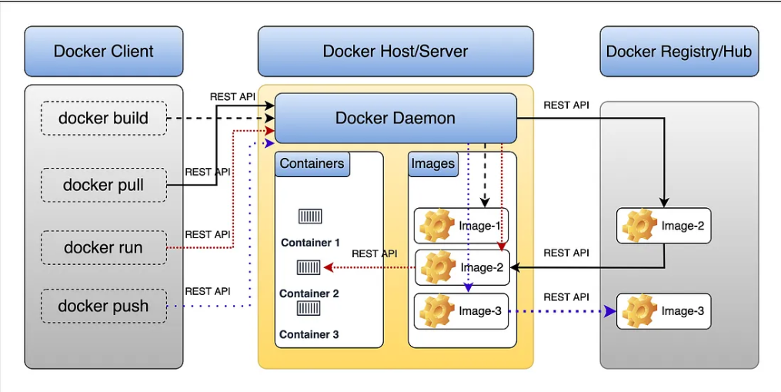

**Docker Architecture**

* Docker uses a client-server architecture. The Docker client talks to the Docker daemon, which does the heavy lifting of building, running, and distributing your Docker containers. The Docker client and daemon can run on the same system, or you can connect a Docker client to a remote Docker daemon. The Docker client and daemon communicate using a REST API, over UNIX sockets or a network interface. Another Docker client is Docker Compose, that lets you work with applications consisting of a set of containers.
* ***Docker daemon:***daemon (dockerd) listens for Docker API requests and manages Docker objects such as images, containers, networks, and volumes. A daemon can also communicate with other daemons to manage Docker services.
* ***Docker client***: is the primary way that many Docker users interact with Docker. When you use commands such as docker run, the client sends these commands to dockerd, which carries them out. The docker command uses the Docker API. The Docker client can communicate with more than one daemon.
* ***Docker registries:*** stores Docker images. Docker Hub is a public registry that anyone can use, and Docker looks for images on Docker Hub by default. You can even run your own private registry.

**What is Docker Image?**

* Docker images are read-only templates that contain instructions for creating a container.
* Docker image is a snapshot or blueprint of the libraries and dependencies required inside a container for an application to run
* An image is composed of multiple stacked layers, like layers in a photo editor, each changing something in the environment. Images contain the code or binary, runtimes, dependencies, and other filesystem objects to run an application. The image relies on the host operating system (OS) kernel.
* Docker images are immutable, so you cannot change them once they are created. If you need to change something, create another container with your changes, then save those as another image. Or, just run your new container using an existing image as a base and change that one.

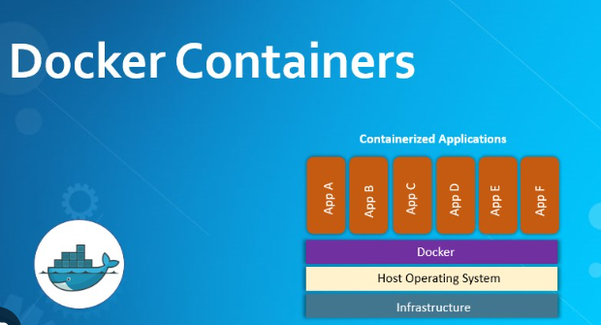

**What are Docker containers?**

* A container is a standard unit of software that packages up code and all its dependencies so the application runs quickly and reliably from one computing environment to another.
* When a Docker user runs an image, it becomes one or multiple container instances. The container’s initial state can be whatever the developer wants — it might have an installed and configured web server, or nothing but a bash shell running as root. In practice, though, most images include some preconfigured software and configuration files.
* A container is an isolated place where an application runs without affecting the rest of the system and without the system impacting the application. Because they are isolated, containers are well-suited for securely running software like databases or web applications that need access to sensitive resources without giving access to every user on the system.

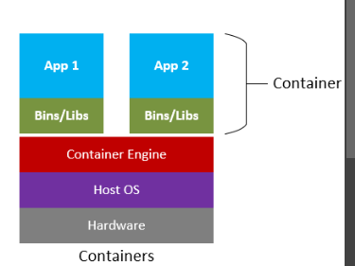

**What are Docker containers images?**

* A Docker container image is a lightweight, standalone, executable package of software that includes everything needed to run an application: code, runtime, system tools, system libraries and settings.
* Container images become containers at runtime and in the case of Docker containers – images become containers when they run on Docker Engine.

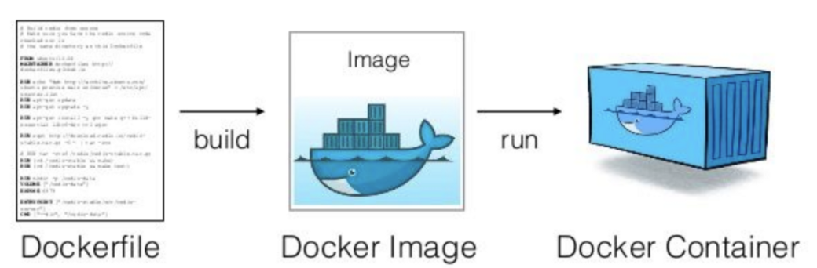

**Why use Docker?**

* It guarantees that if a feature functions in the development environment, it will also work in the production and staging environments. Docker eliminates friction between the two teams and eases the work of automating steps such as testing, staging, and deployment.
* Docker works by providing a standard way to run your code. Docker is an operating system for containers. Similar to how a virtual machine virtualizes (removes the need to directly manage) server hardware, containers virtualize the operating system of a server. Docker is installed on each server and provides simple commands you can use to build, start, or stop containers.
* Use Docker containers as a core building block creating modern applications and platforms. Docker makes it easy to build and run distributed microservices architectures, deploy your code with standardized continuous integration and delivery pipelines, build highly-scalable data processing systems, and create fully-managed platforms for your developers
* Docker streamlines the development lifecycle by allowing developers to work in standardized environments using local containers which provide your applications and services. Containers are great for continuous integration and continuous delivery (CI/CD) workflows.

**Why use containers?**

* Containers are an abstraction at the app layer that packages code and dependencies together. Multiple containers can run on the same machine and share the OS kernel with other containers, each running as isolated processes in user space. Containers take up less space than VMs (container images are typically tens of MBs in size), can handle more applications and require fewer VMs and Operating systems.

1. **Install Docker from** [**https://docs.docker.com/desktop/install/windows-install/**](https://docs.docker.com/desktop/install/windows-install/)

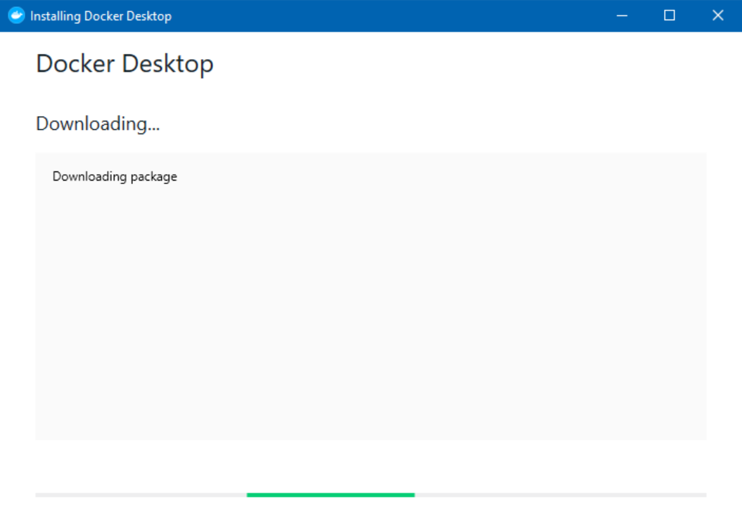

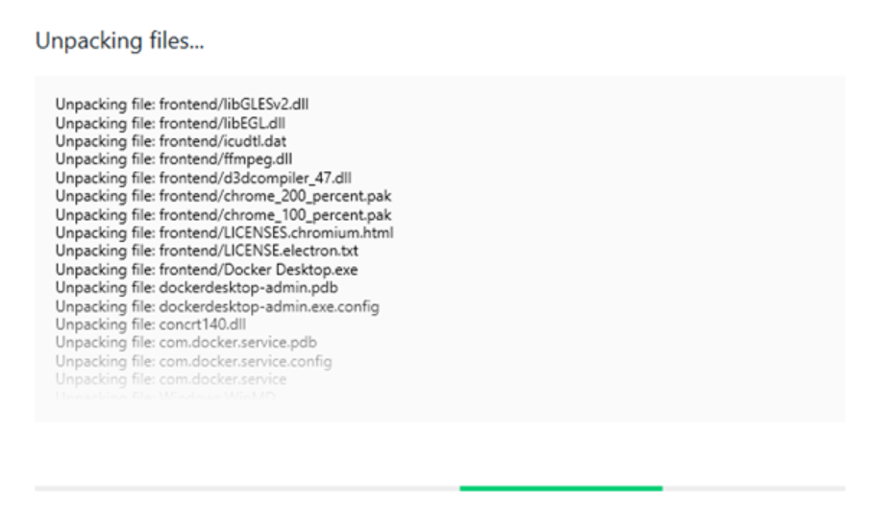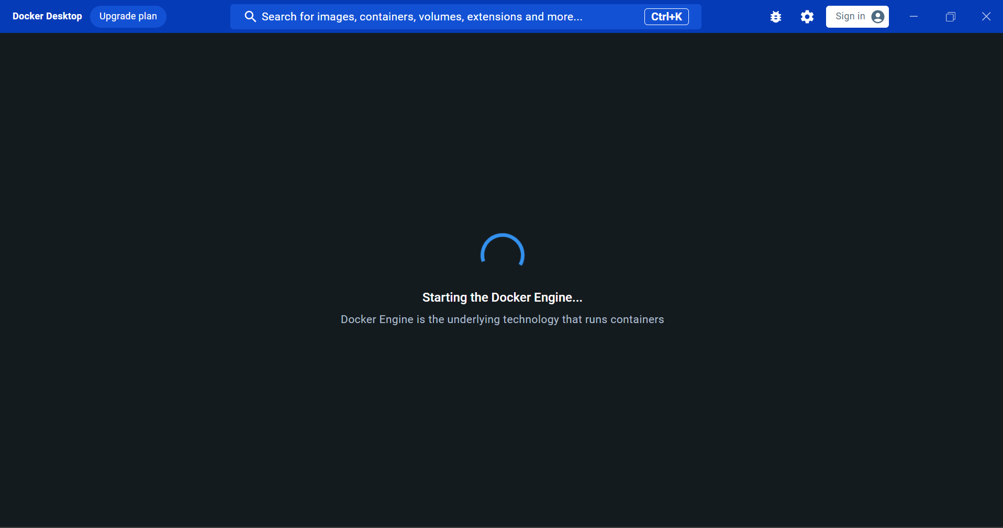

1. **Create a new image Hello World**

* Run on cmd prompt: *docker run hello-world*

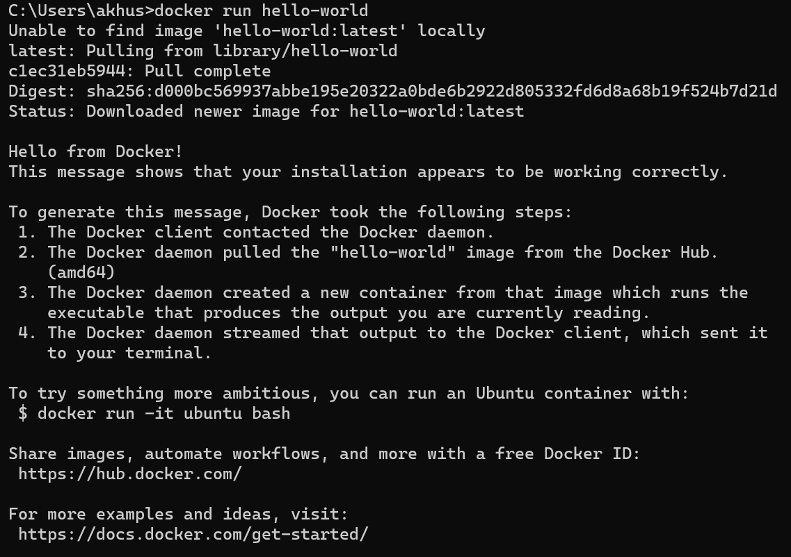

* Hello.c image is downloaded from: <https://github.com/docker-library/hello-world> for the source code of the hello binary included in this image

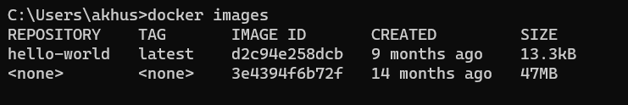

* *Docker ps*
* *Docker ps-a* : This command displays all images including exited running ones

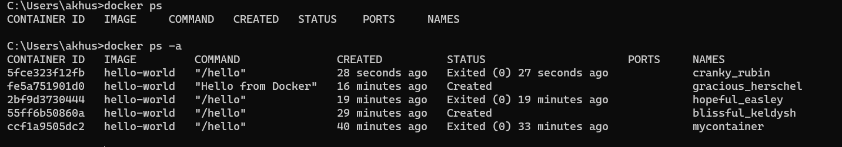

1. **Create an image & containerize it**

* Open cmd and paste
* *docker container create -i -t --name mycontainer hello-world*
* *docker container start --attach -i mycontainer*
* *docker pull hello-world*

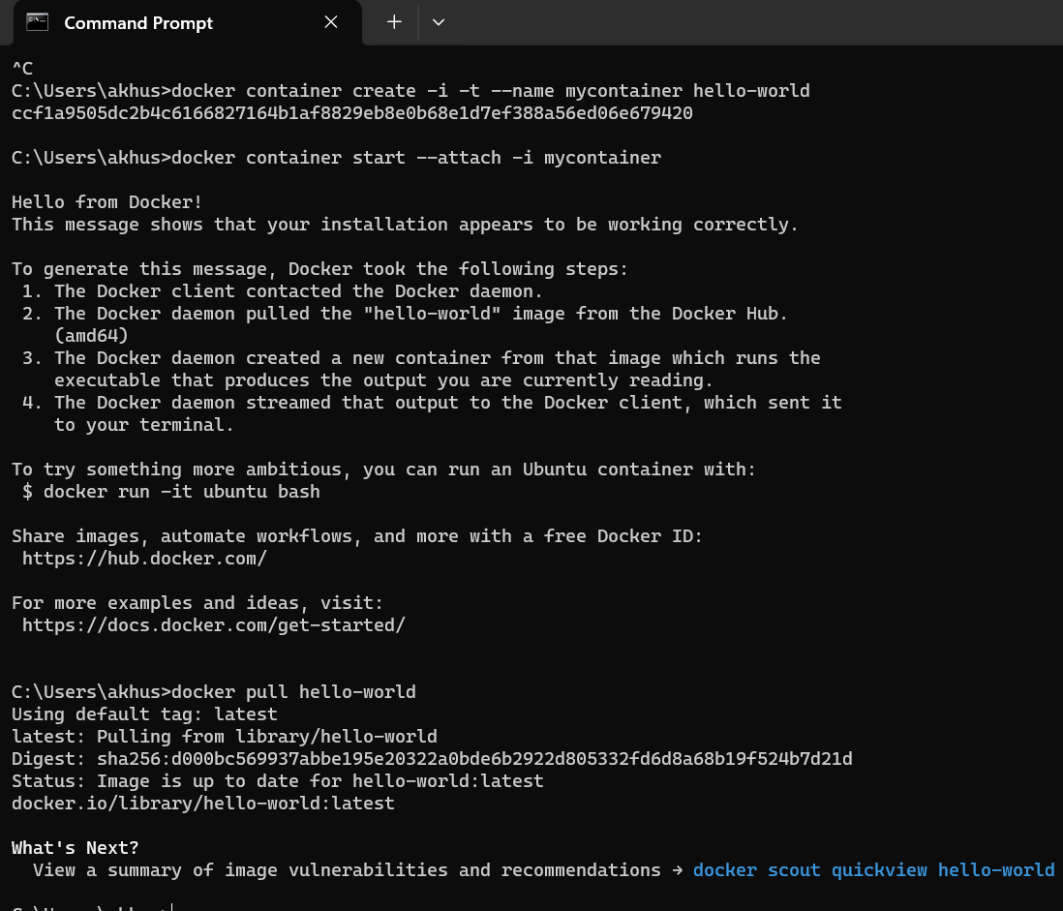

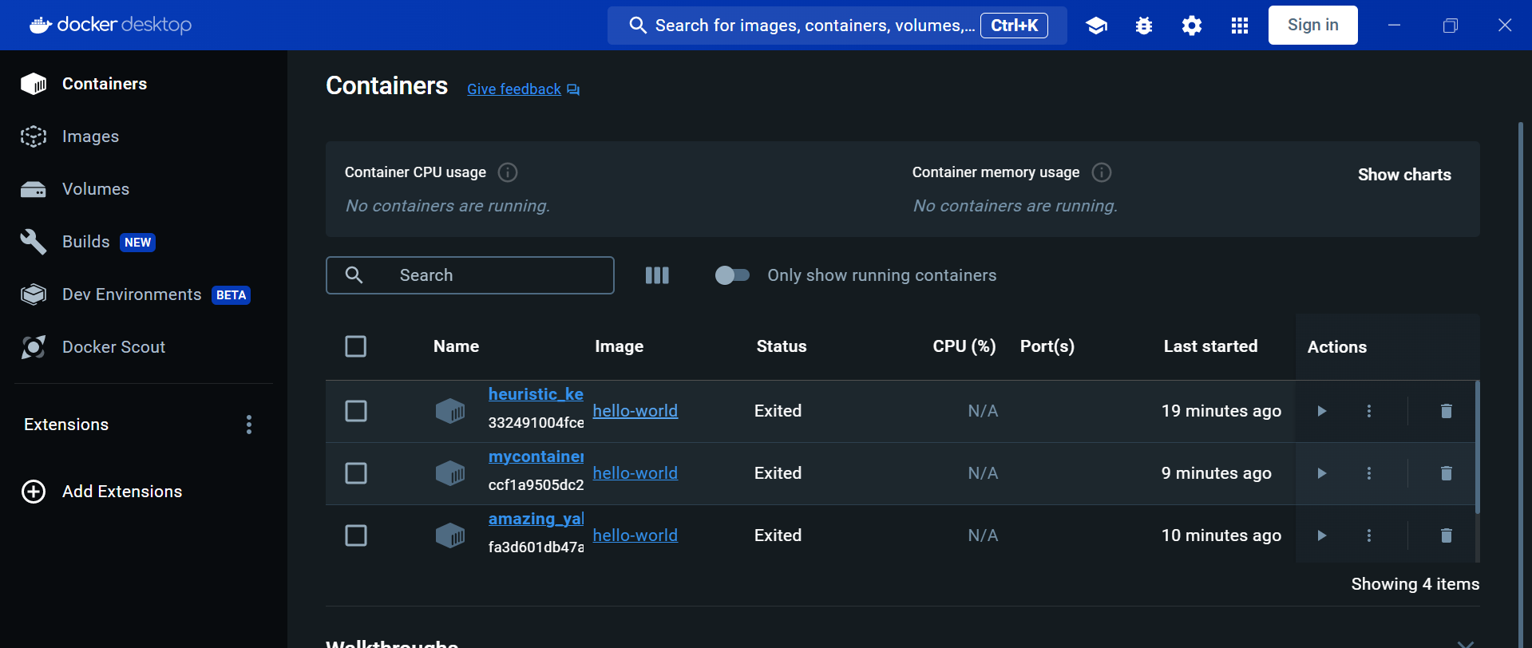

1. **Remove docker image**

* `*Docker image rm hello-world*`
* If image is running `*docker image rm hello-world -f`*



1. **Create an additional application (Python Data visualization)**

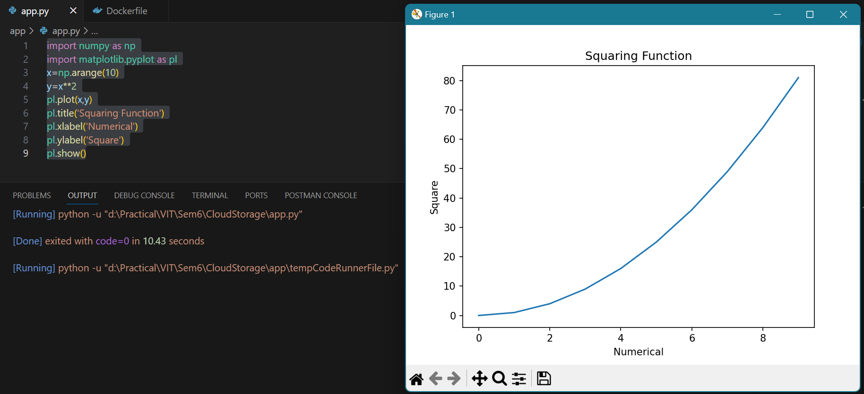

* Create a simple python app

*import numpy as np*

*import matplotlib.pyplot as pl*

*x=np.arange(10)*

*y=x**2*

*print(“This is the squaring function”)*

*print(x,y)*

*pl.plot(x,y)*

*pl.title('Squaring Function')*

*pl.xlabel('Numerical')*

*pl.ylabel('Square')*

*pl.show()*

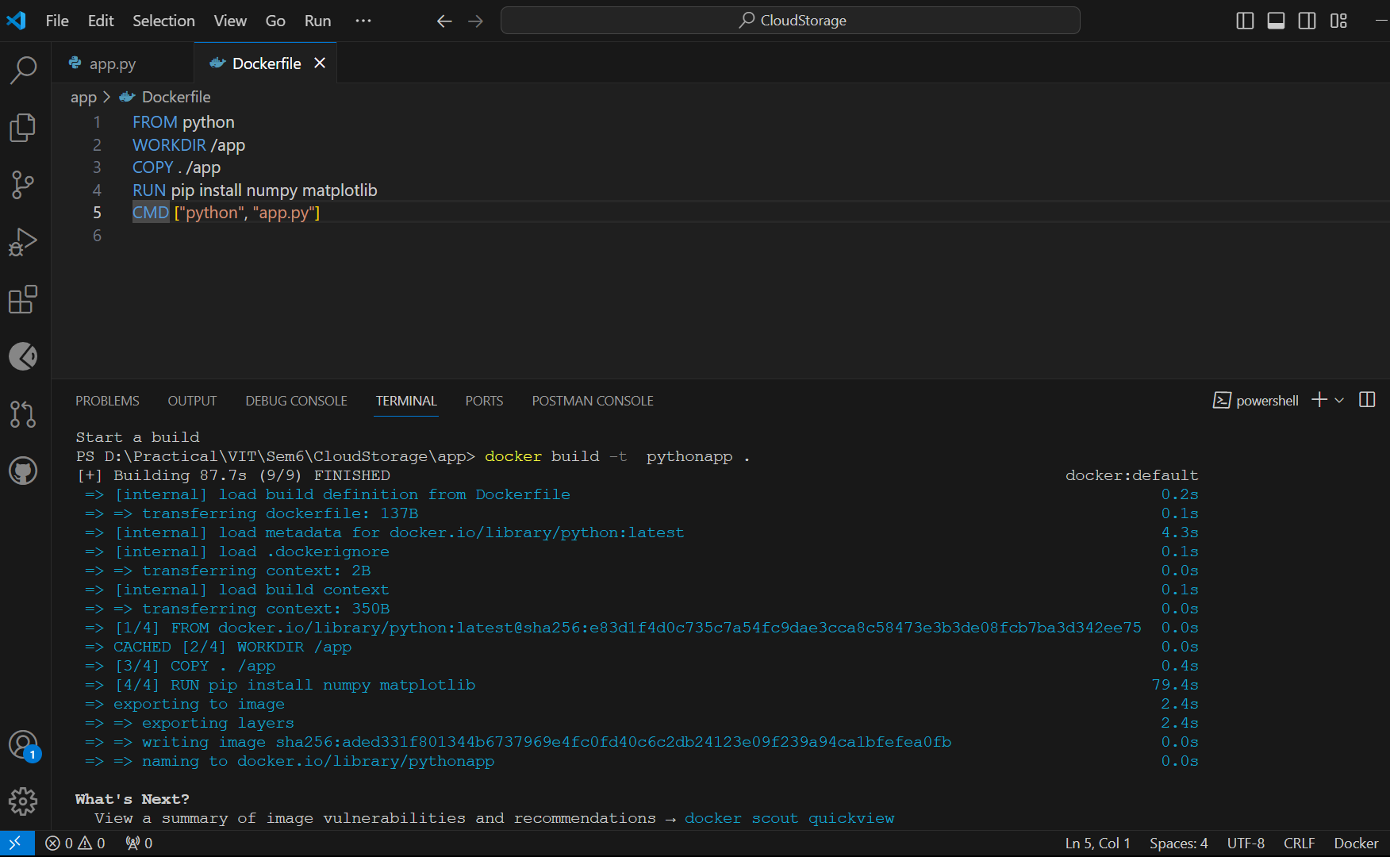

* Create a docker file and ensure to include RUN pip install ~library-name~

*FROM python*

*WORKDIR /app*

*COPY . /app*

*RUN pip install numpy matplotlib*

*CMD ["python", "app.py"]*

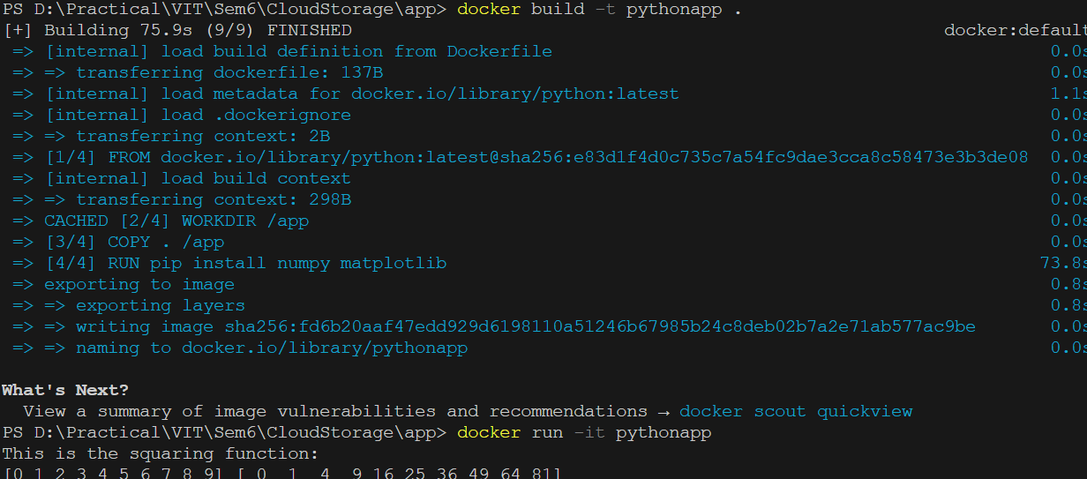

* Now open an integrated terminal by selecting the file from the opened folder. Right click and select open in integrated terminal.
* Type `*docker build -t pythonapp .*` or any other image name used for creation
* `*docker run -it pythonapp*`

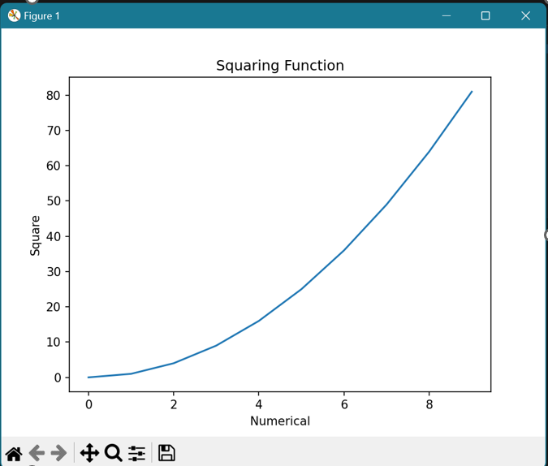

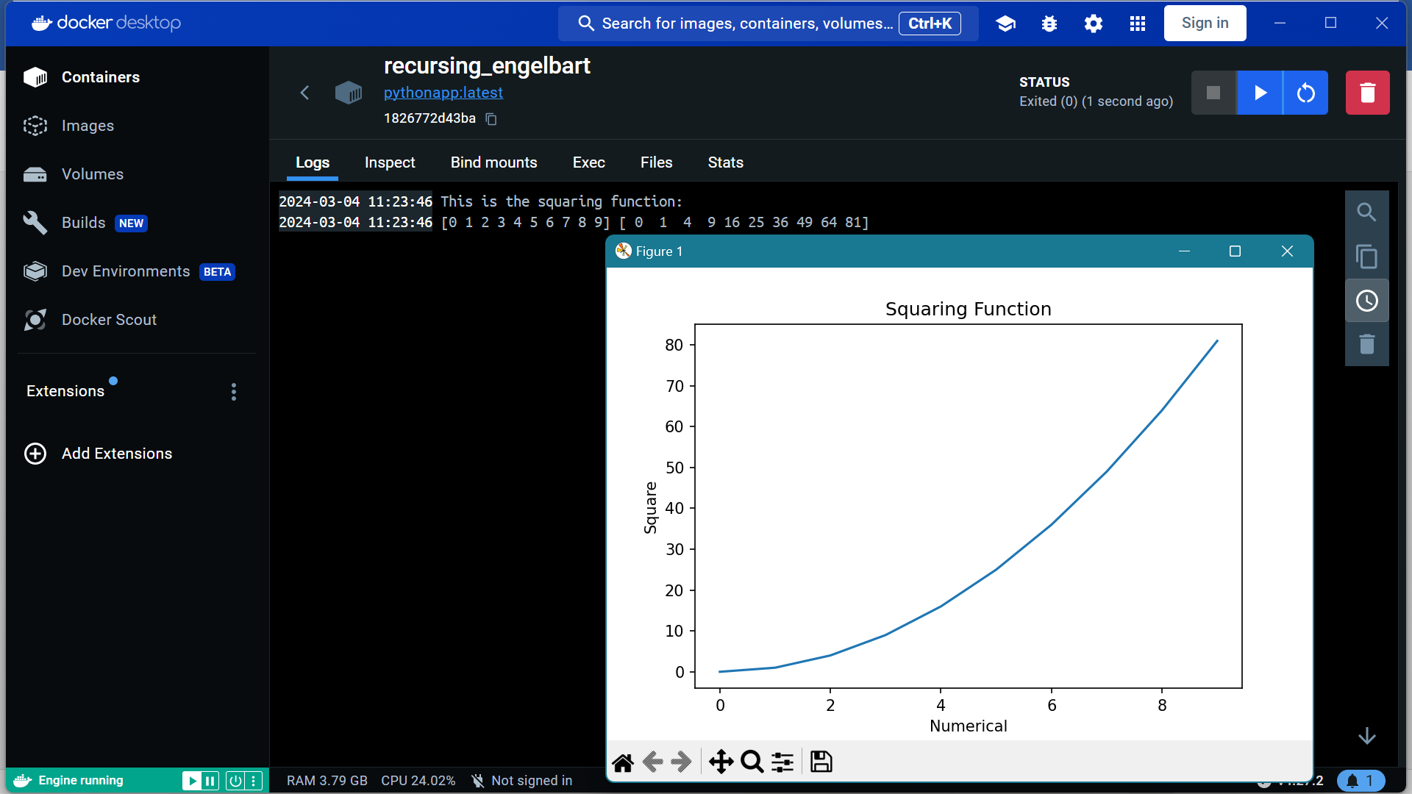

* Go to docker and run the file
* In cmd check all docker images



* After using docker images, remove the files using `docker image rm python -f`



# Experiment Number: 06

**Title:** Deploy a stateless/stateful application on Kubernetes cluster.

|  |  |  |  |
| --- | --- | --- | --- |
| **Title of Experimentation** | **CO**  **Mapping** | **CO-Statements** | **PO**  **Mapping** |
| Deploy a stateless/stateful application on Kubernetes cluster. | CO3 | To evaluate in-depth analysis of Cloud Computing capabilities and its services | PO2  PO3  PO4  PO5  PSO3 |

# Theory:

Kubernetes, also known as K8s, is an open-source system for automating deployment, scaling, and management of containerized applications. It groups containers that make up an application into logical units for easy management and discovery. Kubernetes can help you deliver and manage containerized, legacy, and cloud-native apps, as well as those being refactored into microservices.

Kubernetes, the container-centric management software, has become thede facto standard to deploy and operate containerized applications. Google Cloud is the birthplace of Kubernetes—originally developed at Google and released as open source in 2014. Kubernetes builds on 15 years of running Google's containerized workloads and the valuable contributions from the open source community. Inspired by Google’s internal cluster management system, Borg, Kubernetes makes everything associated with deploying and managing your application easier. Providing automated container orchestration, Kubernetes improves your reliability and reduces the time and resources attributed to daily operations.

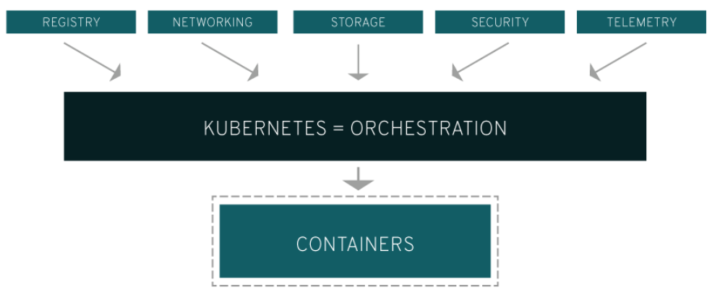

Kubernetes gives you the orchestration and management capabilities required to deploy containers, at scale, for these workloads.Kubernetes orchestration allows you to build application services that span multiple containers, schedule those containers across a cluster, scale those containers, and manage the health of those containers over time. With Kubernetes you can take effective steps toward better IT security.

Kubernetes also needs to integrate with networking, storage, security, telemetry, and other services to provide a comprehensive container infrastructure. Linux containers give your microservice-based apps an ideal application deployment unit and self-contained execution environment. And microservices in containers make it easier to orchestrate services, including storage, networking, and security.

This significantly multiplies the number of containers in your environment, and as those containers accumulate, the complexity also grows. Kubernetes fixes a lot of common problems with container proliferation by sorting containers together into "pods." Pods add a layer of abstraction to grouped containers, which helps you schedule workloads and provide necessary services—like networking and storage—to those containers.

Other parts of Kubernetes help you balance loads across these pods and ensure you have the right number of containers running to support your workloads.

**What is a Kubernetes cluster?**

A working Kubernetes deployment is called a cluster, which is a group of hosts running Linux® containers. You can visualize a Kubernetes cluster as two parts: the control plane and the compute machines, or nodes.

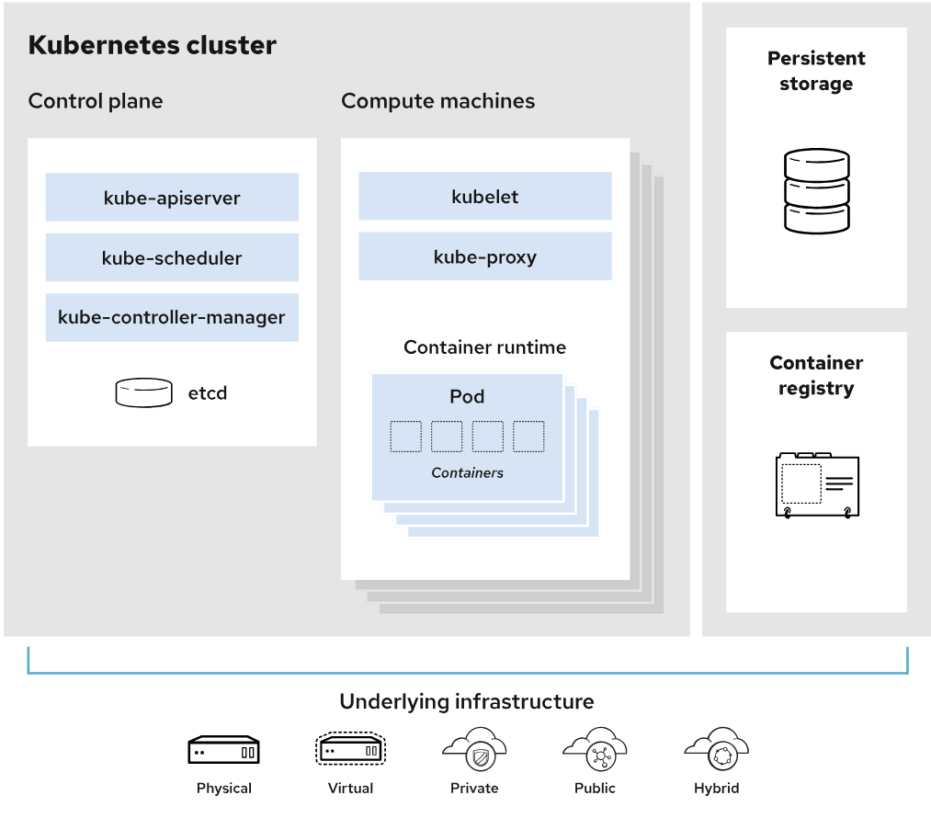

Each node is its own Linux environment, and could be either a physical or virtual machine. Each node runs pods, which are made up of containers.

The control plane is responsible for maintaining the desired state of the cluster, such as which applications are running and which container images they use. Compute machines actually run the applications and workloads. The control plane takes commands from an administrator (or DevOps team) and relays those instructions to the compute machines.

This handoff works with a multitude of services to automatically decide which node is best suited for the task. Services decouple work definitions from the pods and automatically get service requests to the right pod—no matter where it moves in the cluster or even if it’s been replaced. It allocates resources and assigns the pods in that node to fulfill the requested work.

Kubernetes runs on top of an operating system and interacts with pods of containers running on the nodes.

The desired state of a Kubernetes cluster defines which applications or other workloads should be running, along with which images they use, which resources should be made available to them, and other such configuration details.

There is little change to how you manage containers using this type of infrastructure. Your involvement just happens at a higher level, giving you better control without the need to micromanage each separate container or node.

Where you run Kubernetes is up to you. This can be on bare metal servers, virtual machines (VMs), public cloud providers, private clouds, and hybrid cloud environments. One of Kubernetes’ key advantages is it works on many different kinds of infrastructure

**Kubernetes Features**

* **Automated rollouts and rollbacks:** Kubernetes progressively rolls out changes to your application or its configuration, while monitoring application health to ensure it doesn't kill all your instances at the same time. If something goes wrong, Kubernetes will rollback the change for you. Take advantage of a growing ecosystem of deployment solutions.
* **Service discovery and load balancing:** No need to modify your application to use an unfamiliar service discovery mechanism. Kubernetes gives Pods their own IP addresses and a single DNS name for a set of Pods, and can load-balance across them.
* **Storage orchestration**: Automatically mount the storage system of your choice, whether from local storage, a public cloud provider, or a network storage system such as iSCSI or NFS.
* **Self-healing**: Restarts containers that fail, replaces and reschedules containers when nodes die, kills containers that don't respond to your user-defined health check, and doesn't advertise them to clients until they are ready to serve.
* **Secret and configuration management:** Deploy and update Secrets and application configuration without rebuilding your image and without exposing Secrets in your stack configuration.
* **Automatic bin packing:** Automatically places containers based on their resource requirements and other constraints, while not sacrificing availability. Mix critical and best-effort workloads in order to drive up utilization and save even more resources.
* **Batch execution:** In addition to services, Kubernetes can manage your batch and CI workloads, replacing containers that fail, if desired.
* **Horizontal scaling:** Scale your application up and down with a simple command, with a UI, or automatically based on CPU usage.
* **IPv4/IPv6 dual-stack:** Allocation of IPv4 and IPv6 addresses to Pods and Services
* **Designed for extensibility:** Add features to your Kubernetes cluster without changing upstream source code.

**Kubernetes vs. Docker**

Docker can be used as a container runtime that Kubernetes orchestrates. When Kubernetes schedules a pod to a node, the kubelet (the service that makes sure each container is running) on that node will instruct Docker to launch the specified containers.

The kubelet then continuously collects the status of those containers from Docker and aggregates that information in the control plane. Docker pulls containers onto that node and starts and stops those containers.

The difference when using Kubernetes with Docker is that an automated system asks Docker to do those things instead of the admin doing so manually on all nodes for all containers.

**Step 1: Deploy GKE clusters**

* Use Cloud Shell to deploy GKE clusters.



*export my_region=Region*

*export my_cluster=autopilot-cluster-1*

* Create a Kubernetes cluster:





*gcloud container clusters create-auto $my_cluster --region $my_region*

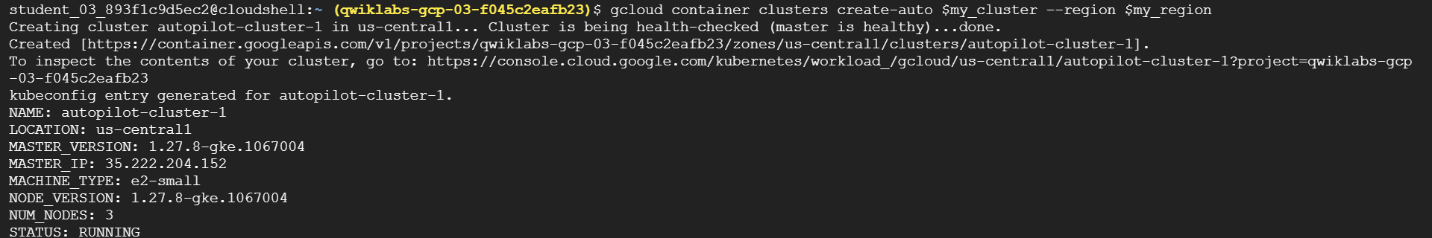

After running for about 5-10mins we see cluster is created with kubeconfig details.

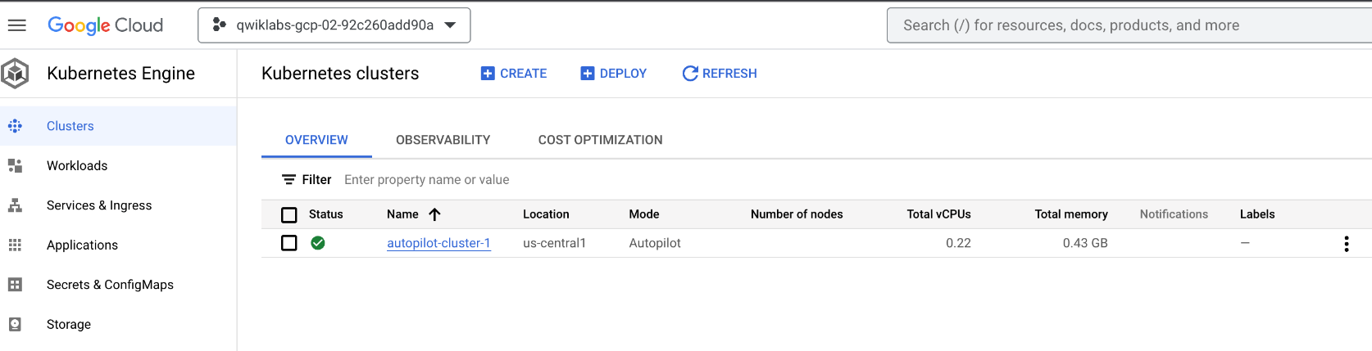

When deployment is complete, the Google Cloud console Kubernetes Engine > Clusters page

**Step2. Connect to a GKE cluster**

To create a kubeconfig file with the credentials of the current user (to allow authentication) and provide the endpoint details for a specific cluster (to allow communicating with that cluster through the kubectl command-line tool)

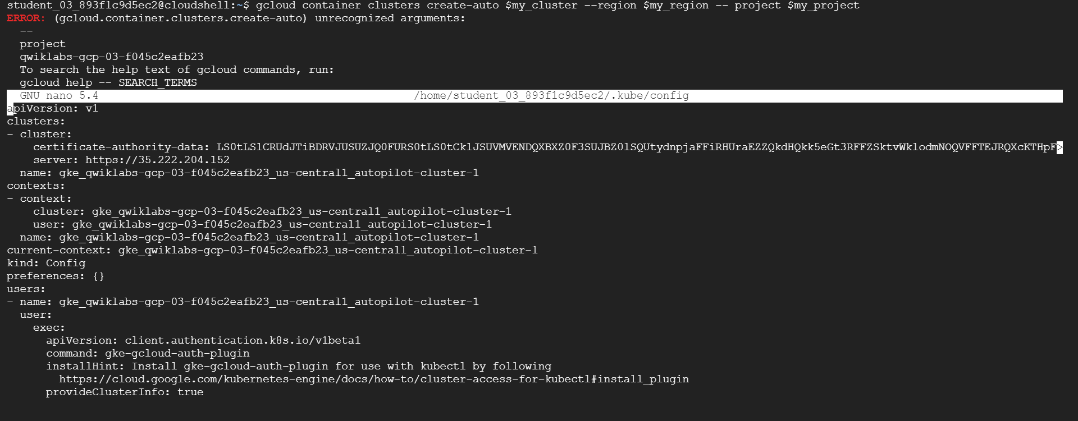

*gcloud container clusters get-credentials $my_cluster --region $my_region*

This command creates a .kube directory in your home directory if it doesn't already exist. In the .kube directory, the command creates a file named config if it doesn't already exist, which is used to store the authentication and configuration information. The config file is typically called the kubeconfig file.

*nano ~/.kube/config*

Press CTRL+X to exit the nano editor.

The kubeconfig file can contain information for many clusters. The currently active context (the cluster that kubectl commands manipulate) is indicated by the current-context property

**Step 3. Use kubectl to inspect a GKE cluster**

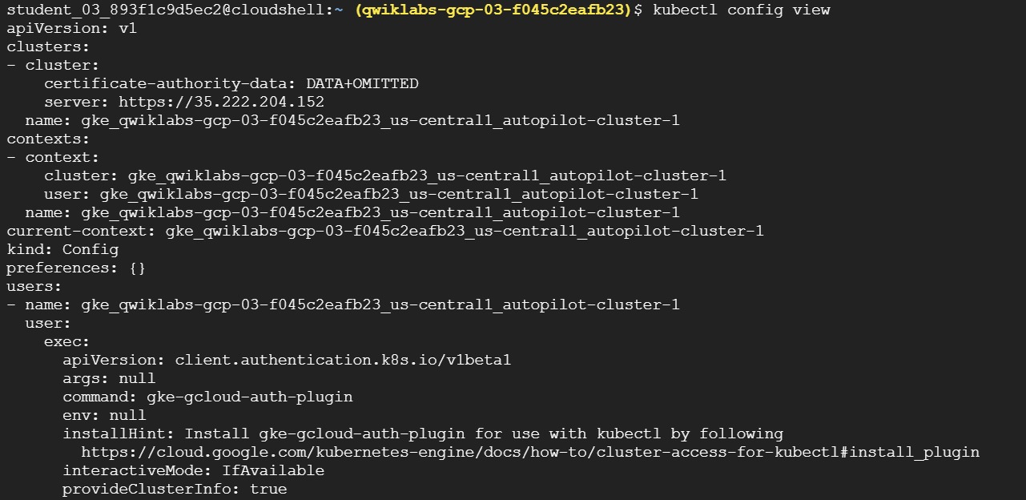

*kubectl config view*

The sensitive certificate data is replaced with DATA+OMITTED.

After the kubeconfig file is populated and the active context is set to a particular cluster, you can use the kubectl command-line tool to execute commands against the cluster. Most such commands ultimately trigger a REST API call against the master API server, which triggers the associated action.

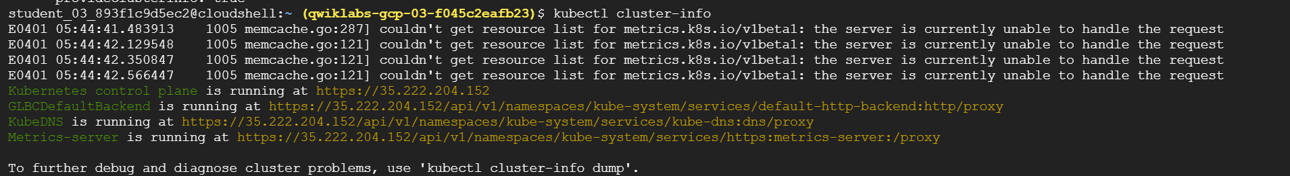

*kubectl cluster-info*

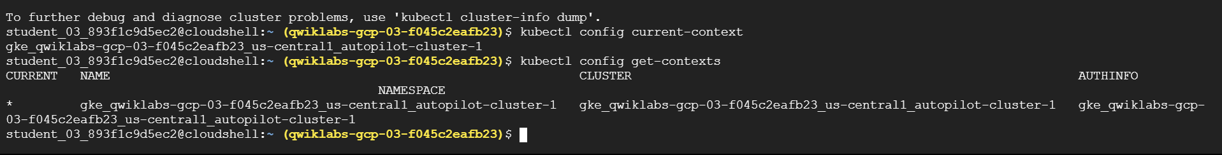

*kubectl config current-context*

*kubectl config get-contexts*

Several lines of output indicate details about the cluster you created and indicate which is the active context cluster. In general, this command lists some details of the clusters present in the user's kubeconfig file, including any other clusters that were created by the user as well as any manually added to the kubeconfig file.

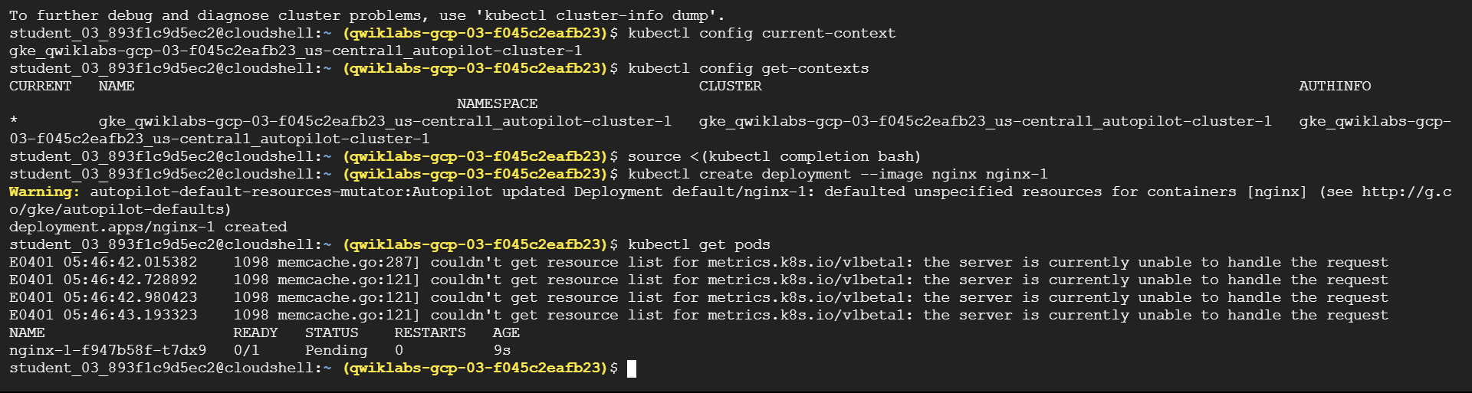

*kubectl config use-context gke_${DEVSHELL_PROJECT_ID}_Region_autopilot-cluster-1*

*kubectl create deployment --image nginx nginx-1*

*kubectl get pods*

*kubectl top nodes*

**Step 4. Deploy Pods to GKE clusters**

Kubernetes introduces the abstraction of a Pod to group one or more related containers as a single entity to be scheduled and deployed as a unit on the same node. You can deploy a Pod that is a single container from a single container image. Or a Pod can contain many containers from many container images.



*kubectl create deployment --image nginx nginx-1*

*kubectl get pods*

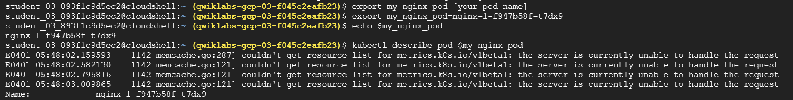export my_nginx_pod=[your_pod_name]

echo $my_nginx_pod



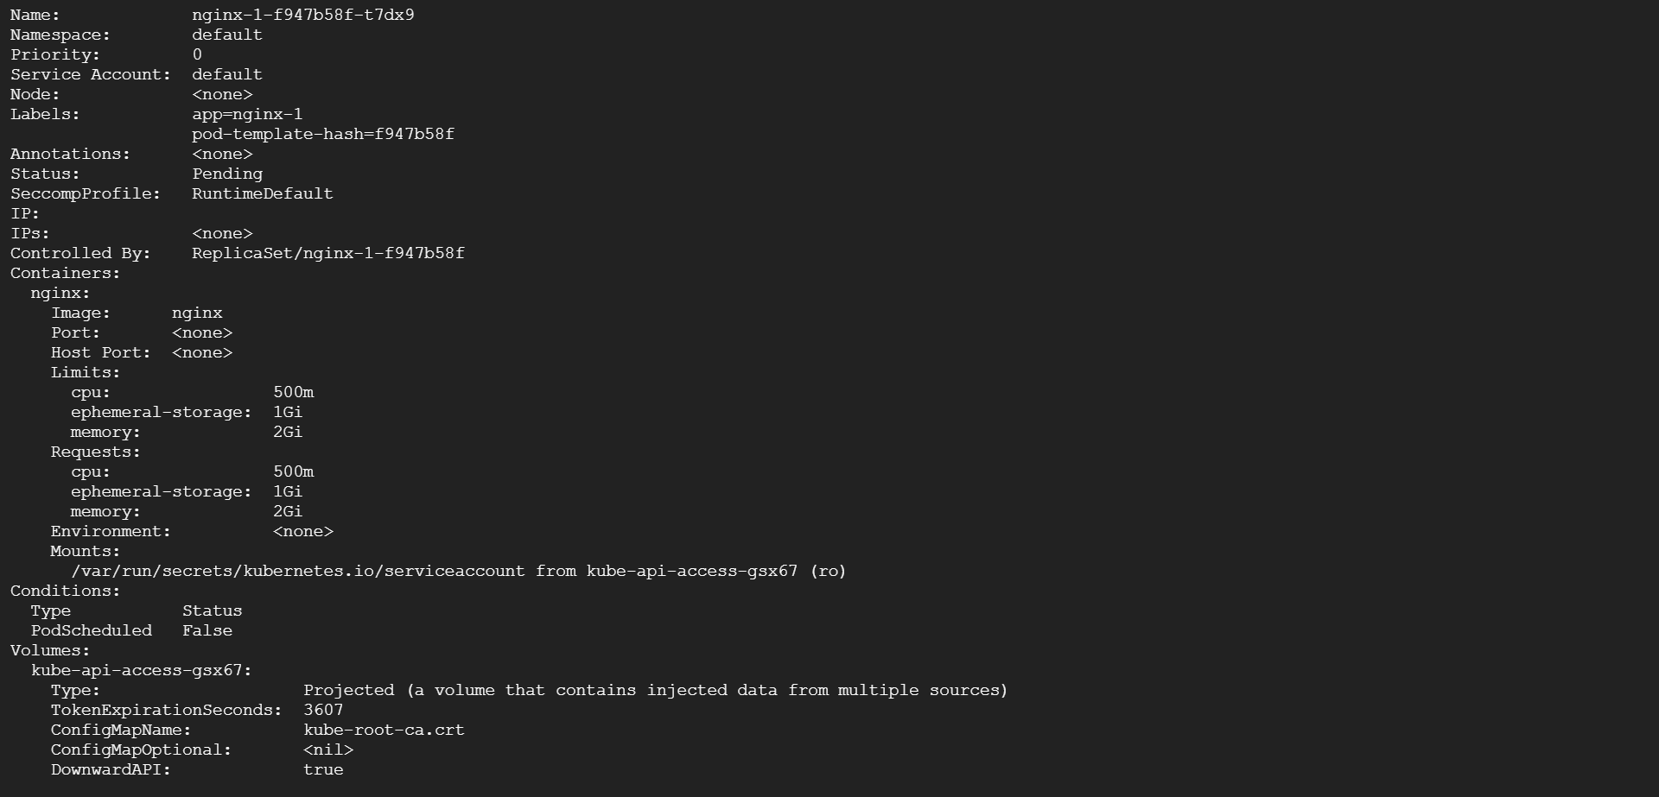

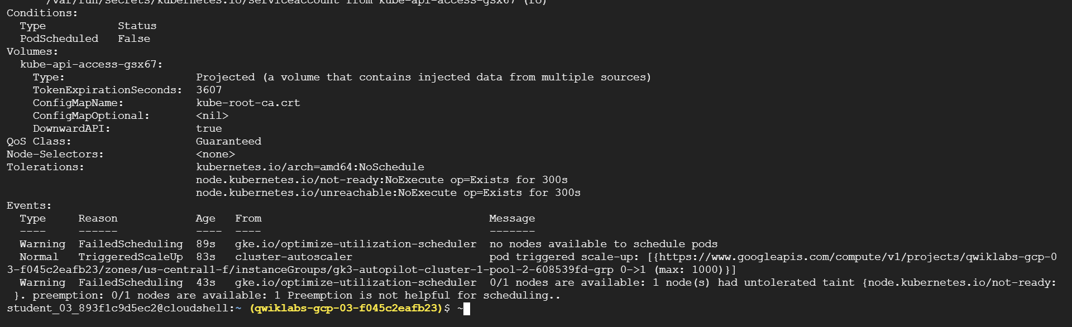

*kubectl describe pod $my_nginx_pod*

Details of the Pod, as well as its status and conditions and the events in its lifecycle, are displayed.

To be able to serve static content through the nginx web server, you must create and place a file into the container.

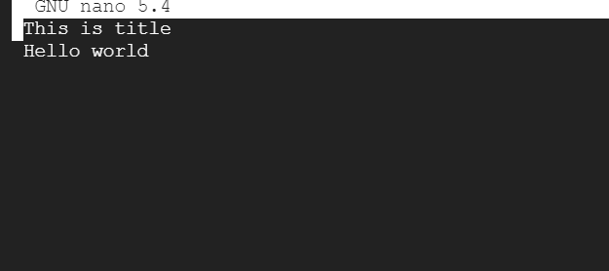

*nano ~/test.html*

Add the following text (shell script) to the empty test.html file:*This is title Hello world*

Press CTRL+X, then press Y and enter to save the file and exit the nano editor.

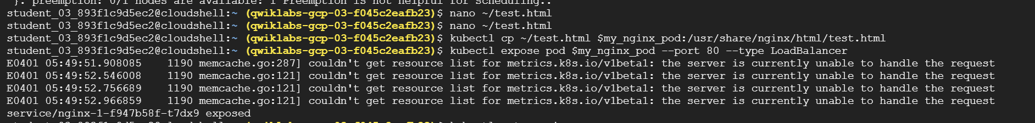

*kubectl cp ~/test.html $my_nginx_pod:/usr/share/nginx/html/test.html*

This command copies the test.html file from the local home directory to the /usr/share/nginx/html directory of the first container in the nginx Pod. You can specify other containers in a multi-container Pod by using the -c option, followed by the name of the container.

*kubectl expose pod $my_nginx_pod --port 80 --type LoadBalancer*

A service is required to expose a Pod to clients outside the cluster. Services are discussed elsewhere in the course and used extensively in other labs.

This command creates a LoadBalancer service, which allows the nginx Pod to be accessed from internet addresses outside of the cluster.

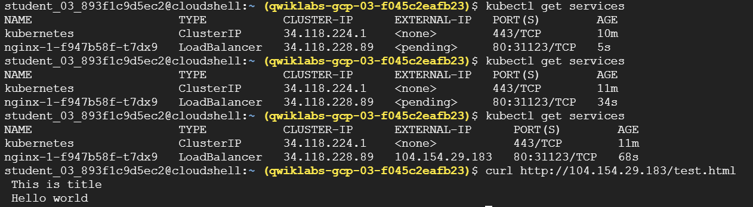

*kubectl get services*

The Kubernetes service is one of the default services created or used by the cluster. The nginx service that you created is also displayed.You may need to re-run this command several times before the external IP address is displayed.

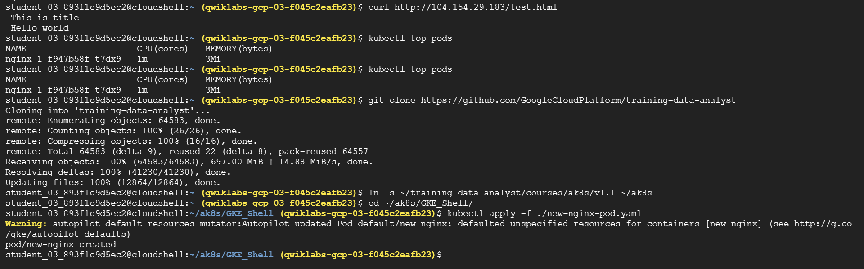

*curl* [*http://[EXTERNAL_IP]/test.html*](http://[EXTERNAL_IP]/test.html)

*kubectl top pods*

